**Ardrossan Academy**

**Music Department**

**S2 Unit 1**

**World Music**

**Homework Booklet**

Name ____________________

Class ____________________



[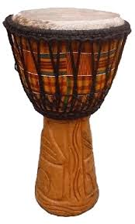](http://www.wizzard-music.de/djembe.gif)[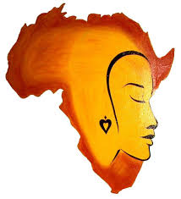](http://www.google.co.uk/imgres?imgurl=http://africanheritageculturalcenter.org/wp-content/uploads/2010/06/Africa1.jpg&imgrefurl=http://www.africanheritageculturalcenter.org/africa.html&usg=__tFOxW2iCgW6Fgg8CGryWS5pLMIY=&h=1053&w=959&sz=79&hl=en&start=32&zoom=1&itbs=1&tbnid=D9iI5phoKkM0FM:&tbnh=150&tbnw=137&prev=/images?q=africa&start=20&hl=en&sa=N&gbv=2&ndsp=20&tbs=isch:1&ei=5CMwTa-wBIixhAfT27ylCw)**Homework 1**

AFRICAN MUSIC

**Read the passage and in your jotter, answer the following questions in sentences.**

Much African music is very traditional and has been handed down from father to son.

Going to an African music concert is much different from going to a classical concert. At an African music concert the audience will join in by clapping, singing or playing an instrument, rather than just sitting and listening to the music quietly. African music sounds very different from European classical music. Although it is nearer to popular music styles, it still seems very unusual to western ears.

African drums are more complex than those found in Europe. Western music is usually played with the same rhythm throughout the piece. African music, however, is often played with a number of rhythms at the same time. This is known as a polyrhythmic style of music. At the heart of African singing is the “call and response” style. In this style a group of singers might sing a line which is repeated or answered by a soloist. African singers also like to put a lot of emotion into their performances as if they were acting a part. They like to shout words and male singers enjoy using their highest register known as falsetto.

African instruments are often made from plants and animal products such as hide and bone. African musicians are very fond of percussion instruments and use a wide variety of drums, clappers, scrapers, gongs and xylophones. Perhaps the most famous African percussion instrument is the “talking drums”. By loosening or tightening the cord around the body of these drums variations in pitch can be produced which are so subtle they sound like the human voice. Stringed instruments such as bows, lyres, lutes, zithers and harps are popular as well as wind instruments like whistles, reed pipes, trumpets and horns.

**Answer the following questions in sentences.**

1. Compare the reaction of an African audience to the music with that of a western audience attending a classical concert.

2. Explain what the following words mean polyrhythmic falsetto.

3. Finish this sentence. In the call and response singing

4. Write three lists of African instruments under the following headings – percussion, string and wind.

5. What are many African instruments made of?

6. Explain how African talking drums are able to copy the sound of the human voice.

**Homework 2**

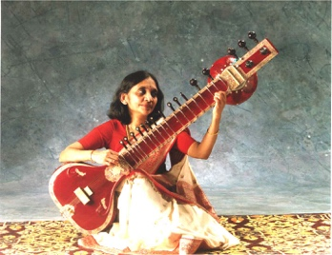

Indian Music

**Read the passage and in your jotter, answer the following questions in sentences.**

Indian Classical Music is one of the oldest forms of music in the world and dates back nearly 2000 years. The classical music of Northern and Southern India is not the same. South Indian music is even older than music from the North, and has developed in a different way. The Southern style of music is called **Carnatic**.

North Indian music is called **Hindustani** and developed from ancient religious chants. These later became influenced by Arabic music in the 11th century when Muslims invaded India. This was the beginning of North Indian classical music, as we know it today.

In the past, classical music flourished in the courts of Indian princes who were called **Maharajas**. The maharajas employed musicians and other artists (such as dancers, actors, storytellers, poets and painters). They lived in the maharajas' palaces and music was rarely heard outside the courts, so there was little contact between court music and any other kinds of music (such as Folk).

Classical Indian music remained pure and traditional for centuries because it was not influenced by other music. Each court had its family of musicians who specialised in a particular style of music. Each musical style was handed down by word of mouth from parent to child through several generations developing an **oral tradition** of teaching Indian music.

Questions.

1. How old is Indian Classical music?

2. How did Indian musicians earn their living in the past?

3. Where was classical music performed?

4. How was the musical teaching passed on?

5. What are the names given to the Northern and Southern styles of Indian Classical Music?

Homework 3

WORLD MUSIC

Your task is to research and report on ‘modern’ music from a country you have been learning about. Find out names of bands and performers over the last 30 years who have had an impact on music in that particular country.

Give details of:

* instruments used in the band/song arrangement
* where bands/artists are from
* what year/era they were popular
* names of popular songs
* who was in the band
* Write your findings in your jotter or make a poster.
* Research at least two different bands/artists.
* 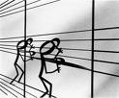You may wish to find out if your parents or any other relatives have any favourites they listened to.

