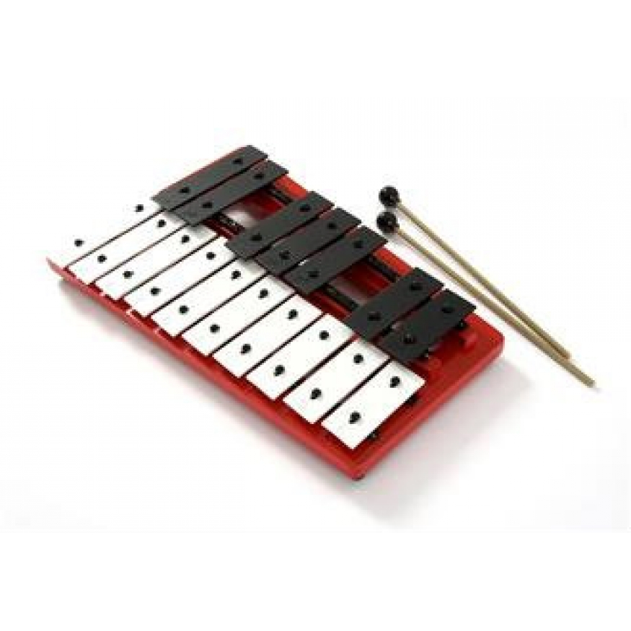Tuned Percussion

Below are some tuned percussion melodies you are going to learn.
They are based on the chord progression C (chord I), F (chord IV), G (chord V) and Am (chord VI).
Try to use 2 beaters and alternate between each.
Lightly bounce the beaters off the keys, letting the sound ring out.

PAPARAZZI
Syncopation – a weak beat in the bar is emphasised

Tone – a distance between two notes equivalent to two semitones
Semitone – the smallest possible distance between two notes
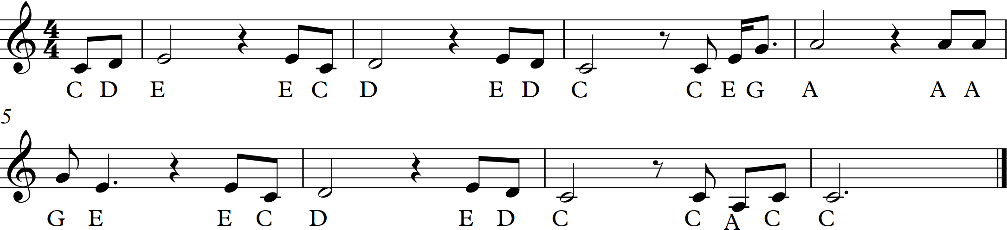
TAKE ME HOME COUNTRY ROADS

Crotchet rest – silence for one beat
Scotch Snap – an accented shorter note followed by a longer one.
G
D
Em
C

LET IT GO
