S1 Keyboard info sheet



Below are some keyboard melodies you are going to learn.

They are based on the chord progression C (chord I), F (chord IV), G (chord V) and Am (chord VI).

Your teacher will help you set up your keyboard to play chords

**C** is made up of the notes C E G but you can the play note C with your left hand

**F** is made up of the notes F A C but you can the play note F with your left hand

**G** is made up of the notes G B D but you can the play note G with your left hand

**Am** is made up of the notes A C E but you can the play notes A & B with your left hand

**Syncopation** – a weak beat in the bar is emphasised

PAPARAZZI

**F**

**Am**

**G**

**C**

**C**



**Semitone** – the smallest possible distance between two notes

**Tone** – a distance between two notes equivalent to two semitones



TAKE ME HOME COUNTRY ROAD

**Am**

**F**

**G**

**C**

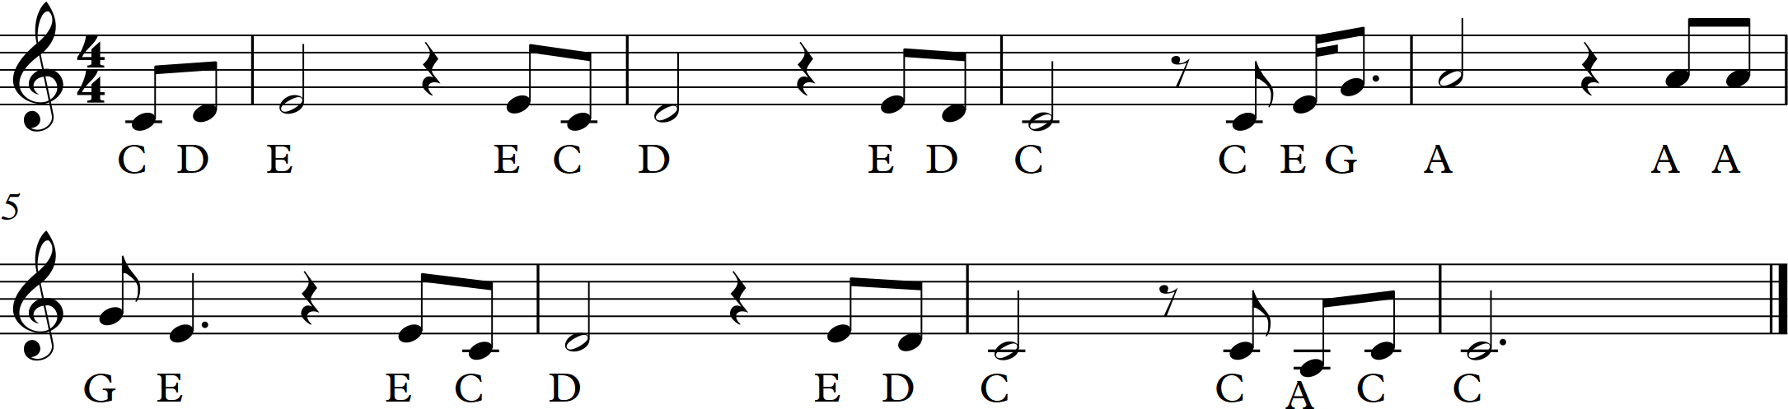

**Crotchet rest** – silence for one beat

**Scotch Snap** – an accented shorter note followed by a longer one.

G

D

Em

C

**C**

**F**

**Am**

**G**

**C**

LET IT GO

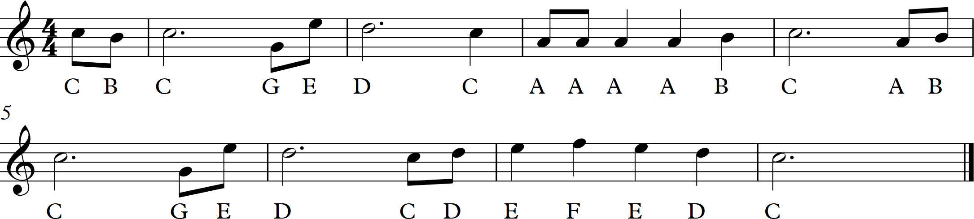

**F**

**Am**

**G**

**C**

**F**

**Am**

**G**

**C**

