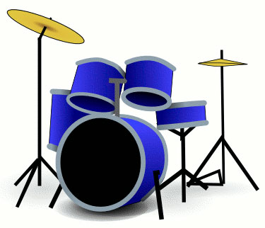
S1 Drum Kit
Rock Rhythm Pattern 1 –
Count: | 1 | & | 2 | & | 3 | & | 4 | &
Hi-hat | X |  | X |  | X |  | X
Snare |  |  | X |  |  |  | X
Bass Drum | X |  |  |  | X

Rock Rhythm Pattern 2 –
Count: | 1 | & | 2 | & | 3 | & | 4 | &
Hi-hat | X | X | X | X | X | X | X | X
Snare |  |  | X |  |  |  | X
Bass Drum | X |  |  |  | X
Rock Rhythm Fill Pattern 1 –
Count: | 1 | & | 2 | & | 3 | & | 4 | &
Snare | X | X
Tom 1 |  |  | X | X
Tom 2 |  |  |  |  | X | X
Tom 3 |  |  |  |  |  |  | X | X
Rock Rhythm Fill – create your own
Count: | 1 | & | 2 | & | 3 | & | 4 | &
Snare
Tom 1
Tom 2
Tom 3
Extension work – Ask your teacher to show you some more complicated patterns and fills

