**S1 Homework Booklet**

Pirates of the Caribbean

NAME ________________________

CLASS ________________________

TEACHER _____________________



HOMEWORK TASK 1 C:\Users\GM9202C\AppData\Local\Microsoft\Windows\Temporary Internet Files\Content.IE5\UVO6QNYC\MC900435937[1].wmf

The music below is the Pirates of the Caribbean theme song. Think of the words you have been using in the melody, harmony and rhythm unit. Using the words below answer the 6 questions! Choose from:

ascending descending step leap repetition sequence question and answer

Write your chosen word in the ovals below. You can use the words more than once!

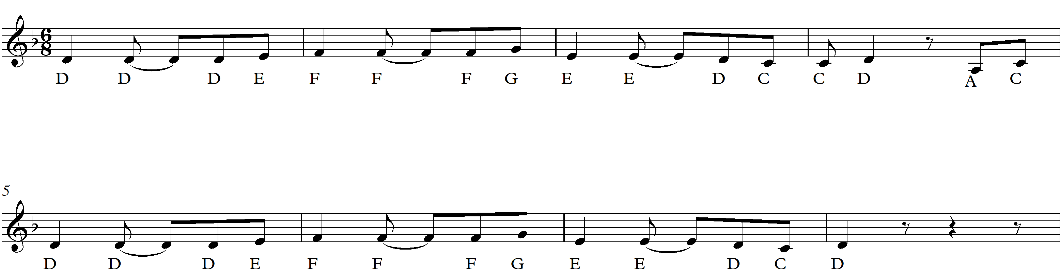

1. Are the circled notes in bar 1 moving by step or leap? Write your answer in the oval above.
2. Are the circled notes in bar 2-3 moving by step or leap? Write your answer in the oval above.
3. What word applies to bars 1-2 (also bars 5-6)? _______________
4. What do you notice about lines 1 and 2? What is the word for this? _______________
5. In bars 1-2 is the music ascending or descending? _______________
6. In bar 3 is the music ascending or descending? _______________

C:\Users\GM9202C\AppData\Local\Microsoft\Windows\Temporary Internet Files\Content.IE5\A9U3IUC0\MC900037177[1].wmf C:\Users\GM9202C\AppData\Local\Microsoft\Windows\Temporary Internet Files\Content.IE5\83SQ4CDY\MC900368446[1].wmf

HOMEWORK TASK 2 

Think about some of the characters we have encountered so far in this unit. Consider what musical words you would use to describe them. Choose **two** of the following characters:

Dory Marlin Davy Jones

  

The Kraken Jack Sparrow

 

When you have chosen your characters, design a poster that uses musical words to describe your characters. Include any **instruments** that you think would describe your chosen characters. Use the internet for pictures!

Use some of the following words:

stepping leaping staccato legato major (happy) minor (sad)

piano (soft) forte (loud) consonance dissonance quickly slowly

**Homework Progress Report**

Please ask your parent/ guardian to read and sign this page when you have completed this booklet. There is also a space for any comments they might have.

|  |  |  |  |
| --- | --- | --- | --- |
| Homework Return | | 1 | 2 |
|  |  |
| Effort |  | Excellent | | |
|  | Very Good | | |
|  | Satisfactory | | |
|  | Unsatisfactory | | |
| Attainment |  | Excellent | | |
|  | Very Good | | |
|  | Satisfactory | | |
|  | Unsatisfactory | | |
| Neatness |  | Excellent | | |
|  | Very Good | | |
|  | Satisfactory | | |
|  | Unsatisfactory | | |

**Teacher’s Signature: Date:**

**Parent Signature: Date:**

Any Comments: