**Larkhall Academy**

**Understanding Music**

**NATIONAL 5**

**Revision Booklet**

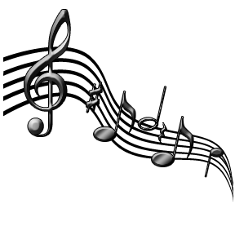

**Helpful Websites**

Type the following into Google and click the first result:

**NQMusic**

**Also try**

**Learn Listening Online** and **Music Listening Revision**

**Important concepts you need to know**

**Homophonic** – **Texture** - all parts move at same time or melody with accompaniment – same rhythms at the same time.

**Polyphonic** – **Texture** 2 or more parts with different rhythms - weave independently of each other. Like **Contrapuntal**

**Legato** – Notes played long and smooth

**Staccato** – Notes played short and detached

**Ostinato/Riff** - Repeated pattern of notes

**Sequence** – Pattern of notes repeated higher or lower

**Repetition** – Musical idea heard more than once.

**Imitation** –The melody is immediately copied in another part.

**Unison** – Same notes at the same time.

**Harmony** – Different notes at the same time.

**Anacrusis** – Tune starts before the first beat of the bar. Think “happy” in happy birthday.

**Syncopation** – Strongly accented notes playing off or against the beat. Will sound more jumpy.

**Symphony** – Piece for **whole orchestra**, no main solo instrument.

**Concerto** – Piece for **soloist** and orchestra

**Cadenza** – passage for soloist to show off, sounds made up – improvised.

**A capella** – Unaccompanied – no accompanying instruments.

**Melismatic** – **More than one** note per syllable.

**Syllabic** – **One** note per syllable.

**Major** – Happy, positive sounding.

**Minor** – Sad, scary, tense sounding.

**Atonal** – Not major or minor – uses dissonance – doesn’t sound nice.

**Forms** - **Binary** – 2 sections – A & B **Ternary** – 3 sections A B A

**Rondo** – Lots of sections with A repeated eg. A – B – A – C–A – D

**Theme & Variations** – Main theme is played and then changed in a different way each variation eg. put into minor key, notes added to tune, different beats in a bar.

**Minuet & Trio** - dance with 3 beats in a bar.

**Alberti bass** - Broken chords played by the left hand on the piano. Low - high – middle – high.

**Walking Bass** – Notes move on every beat.

**Ground Bass** - A theme in the bass which is repeated many times while the higher parts change.

**Broken chord** – Notes of the chord played separately.

**Vamp** – Boom cha accompaniment. Bass note then chord.

**Simple time** – Each beat splits into 2 equal parts – TAN-GO

**Compound time** – Each beat splits into 3 equal parts – JIGG-I-TY.

**Aria** – Main song in an opera. Shows off the singers ability-tuneful.

**Cadence** – Last 2 chords in a phrase.

**Perfect Cadence** = sounds finished

**Imperfect Cadence** = sounds unfinished.

**Tierce De Picardi** – Minor piece last chord major.

**Pedal** – **Low** note held on or repeated while other parts change.

**Inverted Pedal** - **High** note held on/repeated while other parts change

**Modulation** – Change of key.

**Voices – Highest to lowest**

**Soprano**

**Mezzo Soprano** **FEMALE**  
**Alto**

**Tenor**

**Baritone** **MALE**  
**Bass**

|  |  |
| --- | --- |
| **Tempo** | **Meaning** |
| ***Allegro*** | Fast |
| ***Moderato*** | Moderate tempo |
| ***Andante*** | Walking Pace |
| ***Adagio*** | Slow |
| ***Accelerando*** | getting faster |
| ***Rallentando*** | getting slower |
| ***Rubato*** | robbed time – speeding up or slowing down to suit the mood of the piece. |

**TEMPOS – SPEEDS**

**DYNAMICS – LOUDS & QUIETS**

|  |  |  |  |
| --- | --- | --- | --- |
|  | **Dynamic** | **Italian** | **English meaning** |
|  | ***pp*** | *Pianissimo* | very quiet |
|  | ***p*** | *Piano* | quiet |
|  | ***mp*** | *Mezzo-piano* | moderately quiet |
|  | ***mf*** | *Mezzo-forte* | moderately loud |
|  | ***f*** | *Forte* | loudly |
|  | ***ff*** | *Fortissimo* | very loudly |
|  | *cresc.* | *Crescendo* | Gradually getting louder |
|  | *dim.* | *Diminuendo* | Gradually getting softer |

**Instruments & Related Concepts**

**Strings Concepts/Playing Technique**

**Violin Arco -** Bowed

**Viola Pizzicato -** Plucked

**Cello**

**Double Bass**

**Harp** / **Clarsach**

**Woodwind**

**Piccolo Blown -** Air is blown through

**Flute** instrument to produce sound

**Oboe**

**Clarinet**

**Bassoon Flutter Tonguing -** Rolling your Rs while

blowing a note.

**Saxophone**

(not in orchestra)

**Brass**

**Trumpet Con Sordino** **- Muted** - creating a different

**French Horn** sound than normally.

**Trombone** expected.

**Tuba**

**Percussion** **Untuned Percussion**

**Tuned Percussion** Snare Drum Bodhran

Drum-kit Bongo Drums

Xylophone(wooden) Cow Bell Guiro

Glockenspiel(metal) Bass Drum Castanets

Vibraphone Cymbals Tambourine

Timpani (kettle drum) Triangle

Tubular Bells

**Musical Groups / STYLES**

**Orchestra** - Strings, Brass, Woodwind, Percussion

**Brass Band** - Brass & Percussion

**Wind Band** - Brass, Woodwind, Percussion

**Folk Group** - Fiddle, Guitar, Vocals, Accordion,

Whistle, Bass, Flute, Drum kit, Bodhran

**Scottish dance band** - fiddle, accordion, piano, drums.

**Celtic Rock** - Mixes folk music with rock music.

**Reggae** - Off beat guitar, vocals, drums, organ, bass.

**Impressionist** - Sounds dreamy or blurry. Whole tone scale.

**Minimalist** - Simple and repetitive ostinatos.

**Ragtime**  - Piano. Syncopated melody & vamp accomp.

**Blue** - Jazz style, developed from black American folk songs. Tells a story. Flattened notes.

**Swing** - A jazz style performed by a big band.

|  |  |  |  |
| --- | --- | --- | --- |
| **Dance** | **Speed** | **Beats** | **Other features** |
| **Waltz** | Medium | 3 | Only dance with 3 beats |
| **Jig** | Fast | 2 – 6/8 time | STRAWBERRY, compound time, |
| **Reel** | Fast | 4 | TANGO, simple time, flowing |
| **Strathspey** | Medium | 4 | Jumpy, Scotch Snap |
| **March** | Marching speed | 2 or 4 | Steady, strong pulse. |

**Scottish Music**

|  |  |  |  |  |
| --- | --- | --- | --- | --- |
| **Song** | **Who?** | **Where/About?** | **Accomp?** | **Other?** |
| **Waulking Song** | Women | At **work** | No | Beating sound |
| **Bothy Ballad** | Men | **Farm** work | Usually no | Tells story |
| **Gaelic Psalm** | Both | **Church** North Scotland | No | In Gaelic, Call & Response, not nice. |
| **Mouth Music** | Both | **Nonsense made up Gaelic words** | Maybe | Imitating melody of bagpipes |
| **Scots Ballad** | Both | Telling story | Maybe | Lots of verses and chorus, |

**Literacy Tips**

|  |  |  |
| --- | --- | --- |
|  | Name | Length (beats) |
| **http://www.guitarlessonsindumfries.co.uk/wp-content/uploads/2012/04/Semibreve.png** | **Semibreve** | **http://en.wikiaudio.org/images/8/87/Sharpflatnatural.pnghttp://en.wikiaudio.org/images/8/87/Sharpflatnatural.png4** |
| **http://www.scoreexchange.com/png/scores/6/6/5/9566/0/1.png** | **Dotted Minim** | **3** |
| **http://www.scoreexchange.com/png/scores/6/6/5/9566/0/1.png** | **Minim** | **2** |
| **http://mymusicfile.weebly.com/uploads/2/0/5/6/20565530/8169550_orig.jpg** | **Dotted Crotchet** | **http://en.wikiaudio.org/images/8/87/Sharpflatnatural.pnghttp://en.wikiaudio.org/images/8/87/Sharpflatnatural.png1 + 1/2** |
| **http://assets1.ir.charanga.com/resource_library/music%20fundamentals/images/crotchet/thumbnail.jpg** | **Crotchet** | **1** |
| **http://o.quizlet.com/i/jLHGiZF4-IPG6lQRzFKZpQ_m.jpg** | **Dotted Quaver** | **http://en.wikiaudio.org/images/8/87/Sharpflatnatural.png3/4** |
| **http://mymusicfile.weebly.com/uploads/2/0/5/6/20565530/8169550_orig.jpg** | **Quaver** | **http://en.wikiaudio.org/images/8/87/Sharpflatnatural.png1/2** |
| http://www.musicchakra.com/opus/lesson-plans/media/semiquaver.jpg | **Semiquaver** | **1/4** |

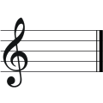**Key Signatures**

**C Major** = 0 sharps or flats

**A Minor** = 0 sharps or flats

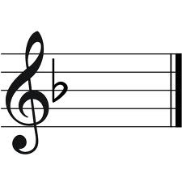 But G#s in music.

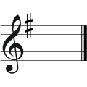 **F Major** = 1 flat *b*

**G Major** = 1 Sharp *#*

**Lines**  **Spaces**

**C:\Users\kinnes\AppData\Local\Microsoft\Windows\Temporary Internet Files\Content.IE5\SH0LSRLX\MC900308762[1].wmf E**very **G**ood **B**oy

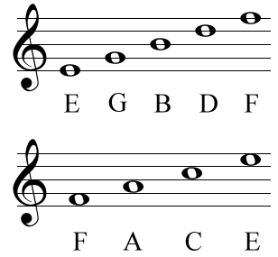 **D**eserves **F**ootball **F A C E**



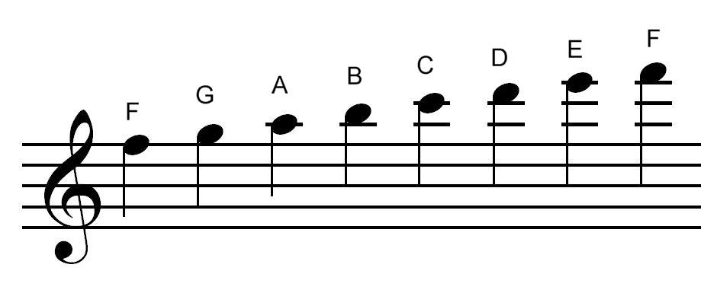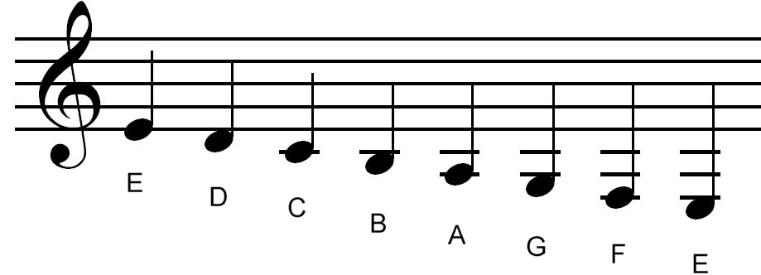Notes below the stave Notes above the stave

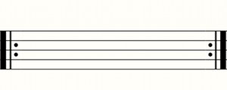**Repeat Signs**

Start End

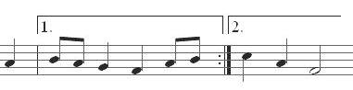

**1st & 2nd time bars**

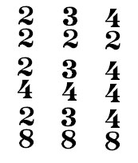**Time Signatures** –go right at the beginning of the first line – **beside the treble clef**.

= 2 crotchet beats per bar = 3 crotchet beats per bar

Simple time Simple time

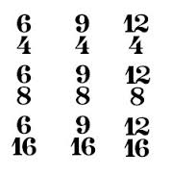

= 4 crotchet beats per bar = 6 quavers per bar (splits Simple time into 2 beats. Compound time

|  |  |  |  |  |
| --- | --- | --- | --- | --- |
| Melody  Harmony | Rhythm  Tempo | Instruments and  how they are used | | Dynamics |
| Repetition  Sequence  Imitation  Modulation  Chords/ Discords  Broken Chords  Suspensions  **Scales**: Major/Minor, Chromatic, Pentatonic  Question & Answer  Glissando  Homophonic/  Polyphonic  Ornaments: trill, grace notes  Legato /Staccato  Unison/Harmony  Pedal  Melismatic/  Syllabic | Syncopation  Repetition  Ostinato  Anacrusis  Beats in a bar /  Time Signature:  2/4, 3/4, 4/4, Simple Time  6/8 – Compound Time  Speed: Allegro – Fast  Adagio – Slow  Andante – walking pace  Moderato – moderate  Speed Changes:  Accelerando – faster  Rallentando – slower  Rubato – with freedom  Dotted Rhythms  Scotch Snap | **Brass** – Trumpet, French Horn, Trombone, Tuba  **Woodwind** – Piccolo, Flute, Oboe, Clarinet, Bassoon, Saxophone, Recorder  **Strings** – Violin, Viola, Cello, Double Bass, Harp  **Percussion** – Xylophone, Glockenspiel, Timpani, Triangle, Snare Drum, Drumkit, Bass Drum, Tambourine, Castanets  **Keyboard** – Piano, Synthesizer, Harpsichord, Organ, Celeste  **Voices** – Soprano, Mezzo Soprano, Alto, Counter Tenor, Tenor, Baritone, Bass  **Guitars** – Electric, Acoustic, Bass, Banjo  Solo, Melody, Countermelody  Accompaniment, Chords, Broken Chords  Glissando, Arpeggios  Arco – bowed, Grace notes, ornaments  Muted, Pizzicato - plucked  Col Legno – wood of bow, Double Stopping  **Female**: Soprano, Mezzo Soprano, Alto  **Male**: Tenor, Baritone, Bass  Countertenor – high like a woman.  Solo; Accompaniment; Melody; Countermelody | *pp – pianissimo – very quiet*  *p – piano* – quiet.  *mp* – *mezzo piano* – moderately quiet.  *mf* – mezzo forte – moderately loud.  *f – forte* – loud.  *ff – fortissimo* – very loud  **Changes of dynamic**  **crescendo** – getting louder  **diminuendo** – getting quieter. | |

**Categories**

**TONALITY**

**MAJOR MINOR ATONAL**

**STRUCTURE**

**BINARY FORM TERNARY FORM RONDO FORM**

**THEME & VARIATION STROPHIC**

**TEXTURE**

**HOMOPHONIC POLYPHONIC/CONRAPUNTAL**

**PERIODS OF MUSIC**

**BAROQUE CLASSICAL MODERN**

**National 5 – Understanding Music Paper LAYOUT**

**Question 1a-f** - **6 Marks**: **Multiple Choice** with a few “write the word” questions.

**Question 2: Box question (musical map) - 4 Marks**

4 numbered boxes. Voice says the number over the music & you must answer the question in the related box when the number is said.

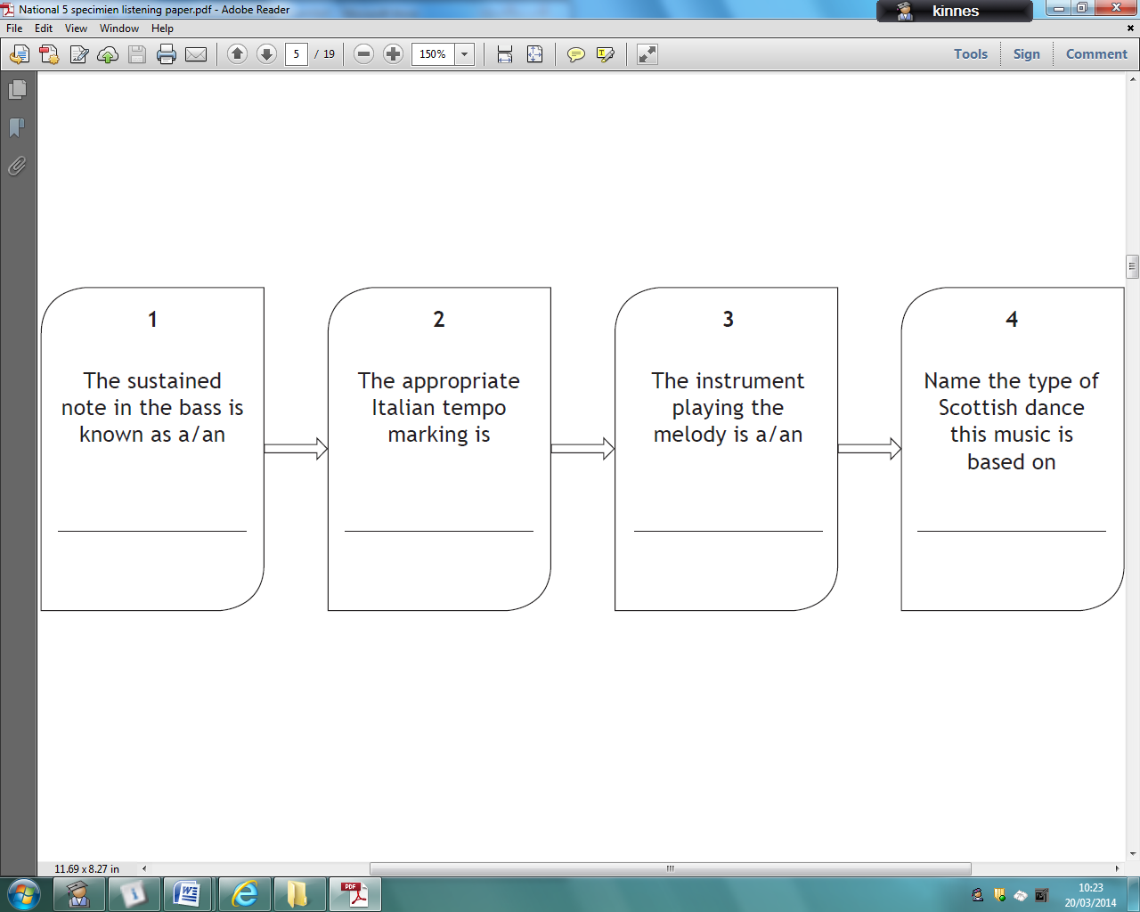

**Question 3: Literacy Question – 6 Marks**

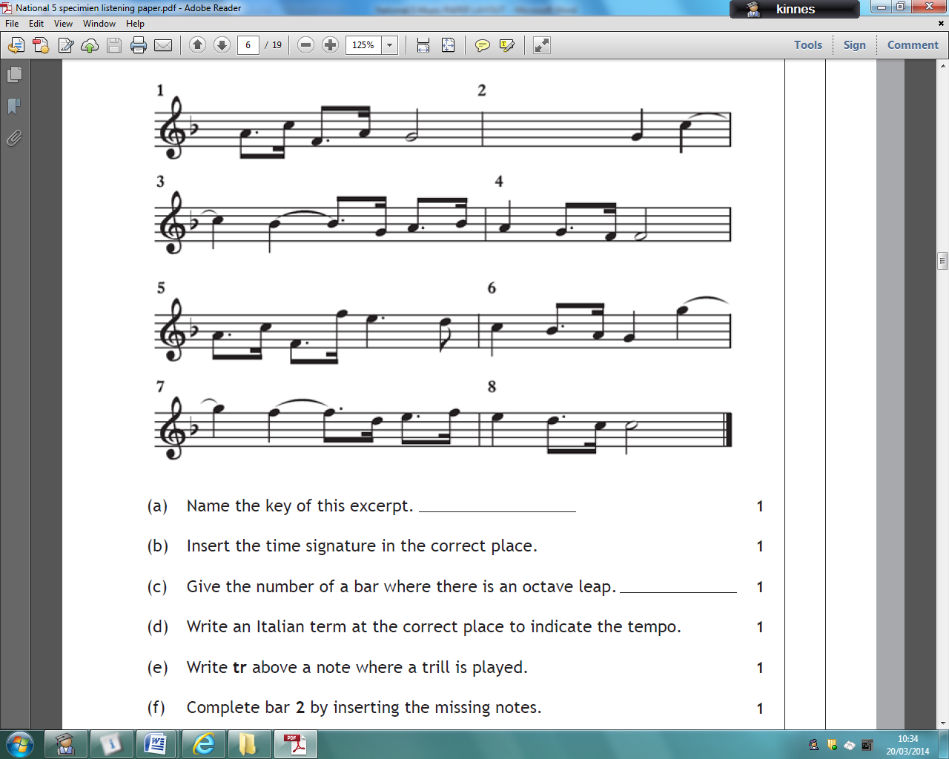Eg. Name the **key** of this piece, insert the **time signature**, insert **missing notes**, insert repeat sign, identify octave leaps, write dynamics, write tempo marks.

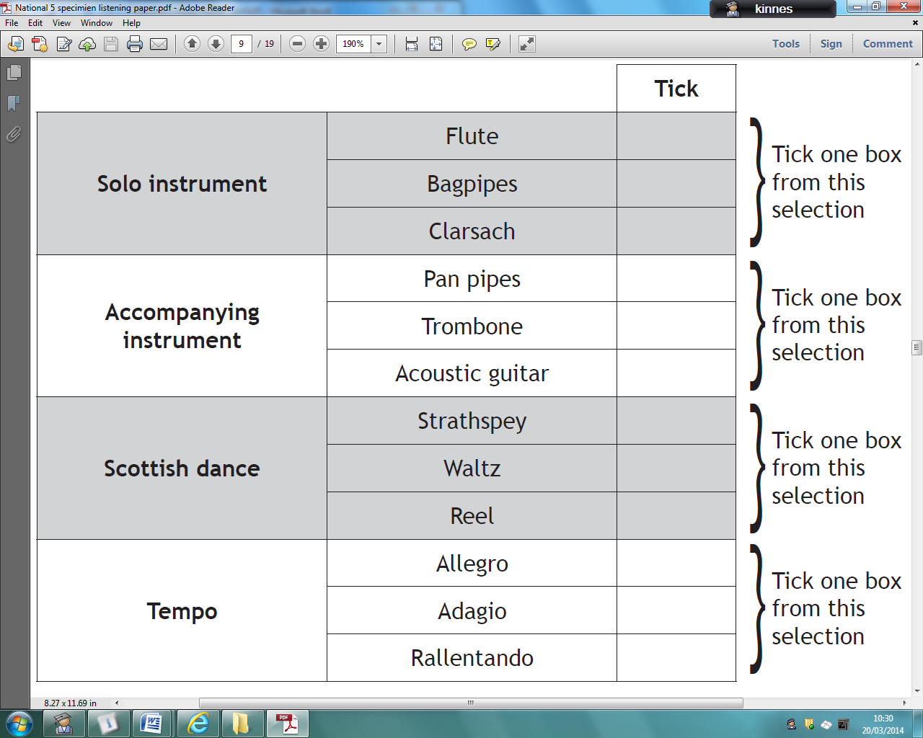**Question 4: Multiple Choice – 8 Marks**

**Question 5: - 4 Marks**

Tick one box from

each section.

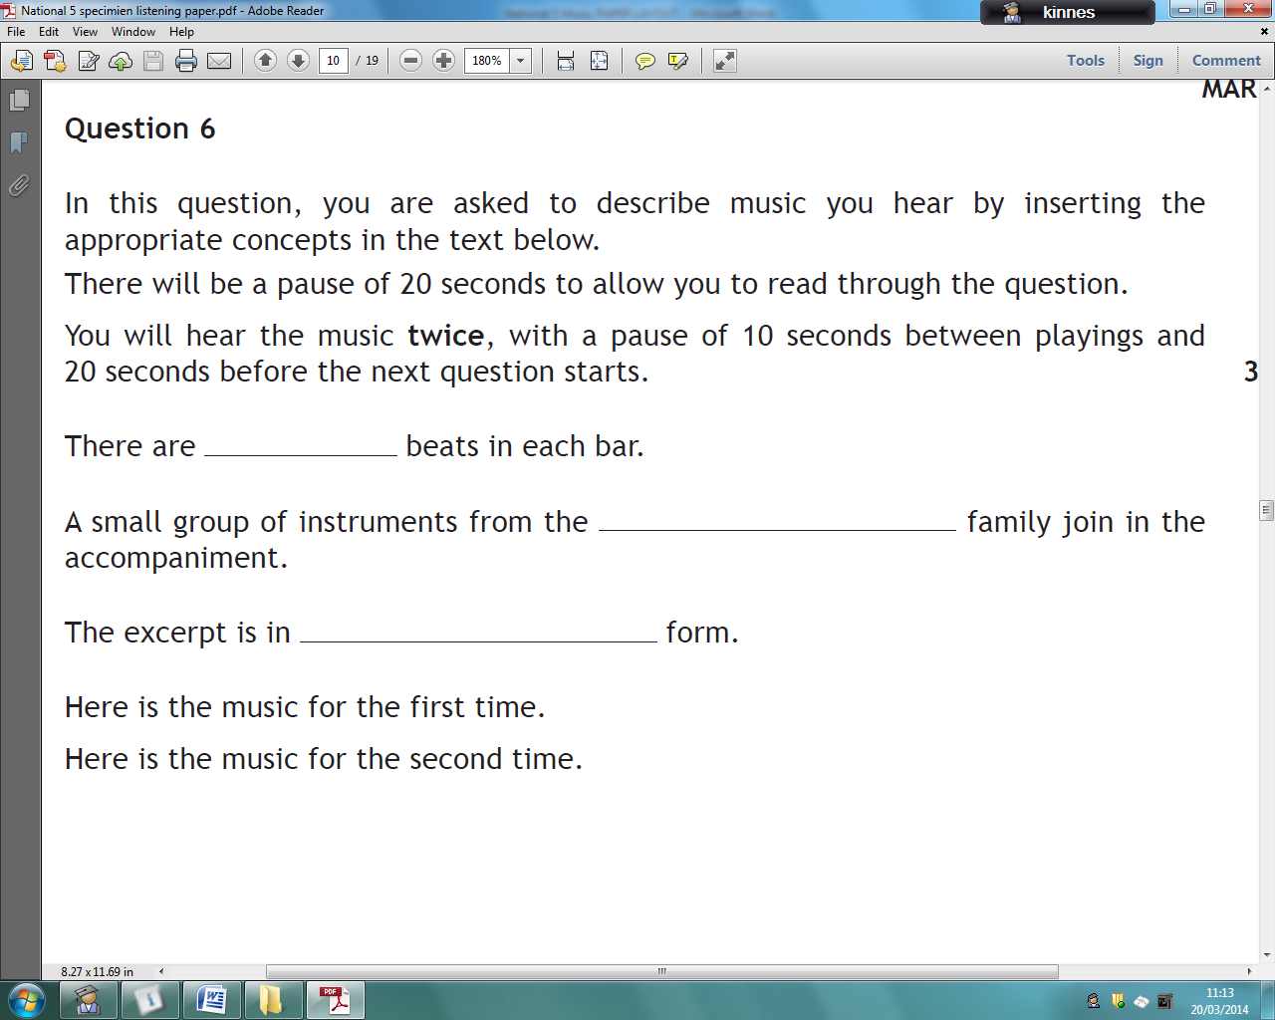**Question 6: Fill in the missing words – 3 Marks**

**Question 7: - 4 Marks - Reason Question**: Multiple choice plus write reason for answer.

**Question 8: - 5 Marks**  Write about the prominent features you hear in the music.

**Fill out this box** then transfer it to the lines on the next page.

|  |  |
| --- | --- |
| **rhythm/tempo** |  |
| **melody/harmony** |  |
| **Instruments/voices and how they are used** |  |
| **dynamics** |  |