ARDROSSAN ACADEMY

MUSIC DEPARTMENT

PERFORMING

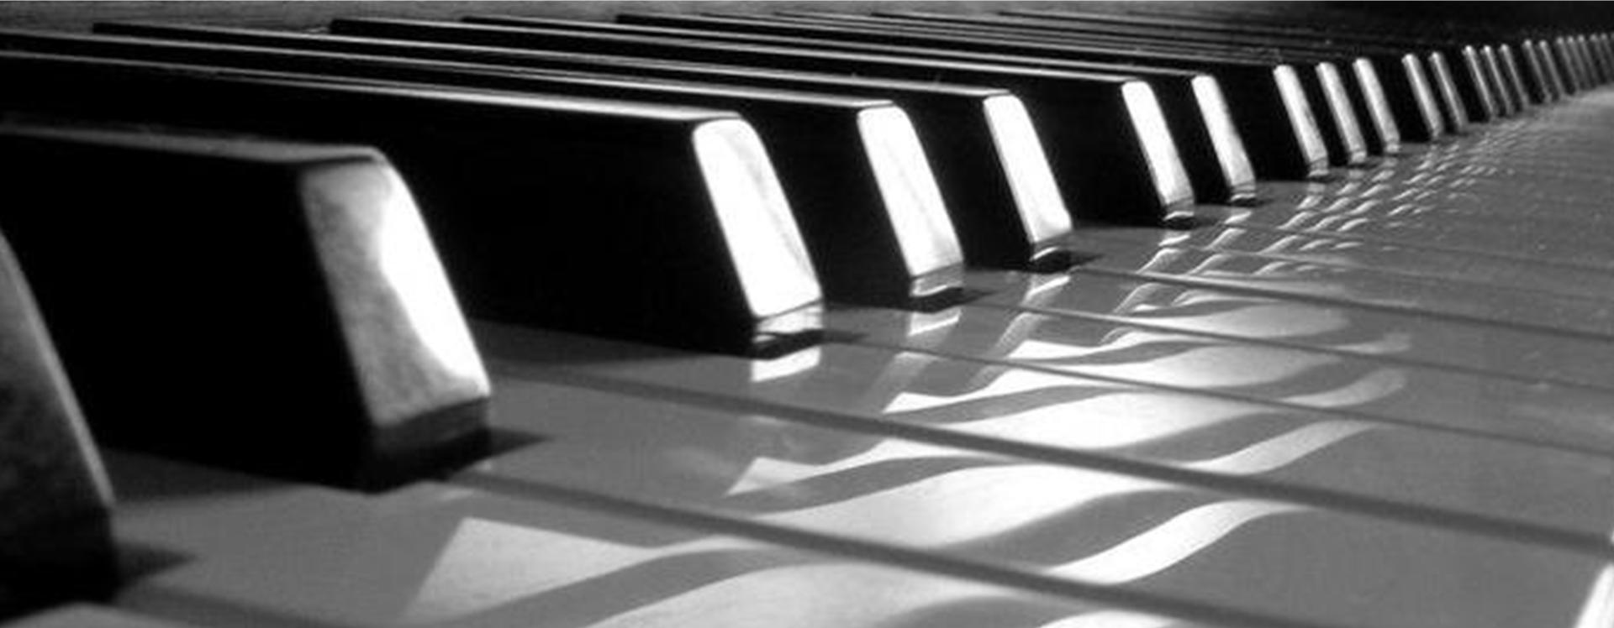

LEVEL 2 – NATIONAL 5

KEYBOARD

MUSIC COURSE



**Requirements**

**Bronze**

I can play the melody and rhythm with some accuracy, while playing left hand chords. I can follow the music notation and understand where the notes are in relation to the stave. I might have to stop in my performance to check notes and chords.

**Silver**

I can play the melody and rhythm accurately most of the time, while playing left hand chords, and can understand most of the information on notes and rhythms given in the notation. I have started to add a backing rhythm, although I might have to slow down to help get through difficult sections of music.

**Gold**

I can play the melody and rhythms accurately with left hand chords and understand how these relate to the music notation. The music flows throughout and I can play confidently along with a backing rhythm. I have some understanding of the music symbols in the notation, including accidentals and dynamics.

**I will know I am successful when I can:**

* Use a correct hand position
* Play the melody notes accurately with my right hand only
* Play the correct rhythm
* Add my left hand playing chords
* Play with an accompaniment

**You should complete 2 pieces of music at each level and perform them for your teacher before moving on.**

CONTENTS

LEVEL 2

Bye Bye Love (38 secs)

Merrily We Roll Along (38 secs)

Little Bird (39 secs)

Love Me Tender (20 secs)

LEVEL 3

Monkey Business (1min 20)

Counting Stars (20 secs)

Heathens (21 Pilots) (20 secs)

Fight For this Love (1min 5)

Shape of You (30 secs)

LEVEL 4

Yellow (1min)

Budapest (1min)

Mad World (1min 5)

Pirates of the Caribbean (40 secs)

Ruby (1min 30)

Domino (1min 30)

Slow Rock (1 min 50)

NATIONAL 5

Little Brown Jug (1min 5)

Stitches (1min 40)

American Patrol (2min 20)

Carnival de Paris (2min)

Theme from Friends (1min 50)

Wrecking Ball 1min 10)

When I’m 64 (2min 45)

Bohemian Rhapsody (2mins)

In Dreams (2min 45)

Paradise (1min 25)

The Rose (1min 35)

Tetris (1min)

LEVEL 2

Bye Bye Love

LEVEL 2

38 seconds

Tone – Strings

**Minim – this note gets 2 beats**

Rhythm – Rock/Pop

**Semibreve – this note gets 4 beats**

Tempo - 100

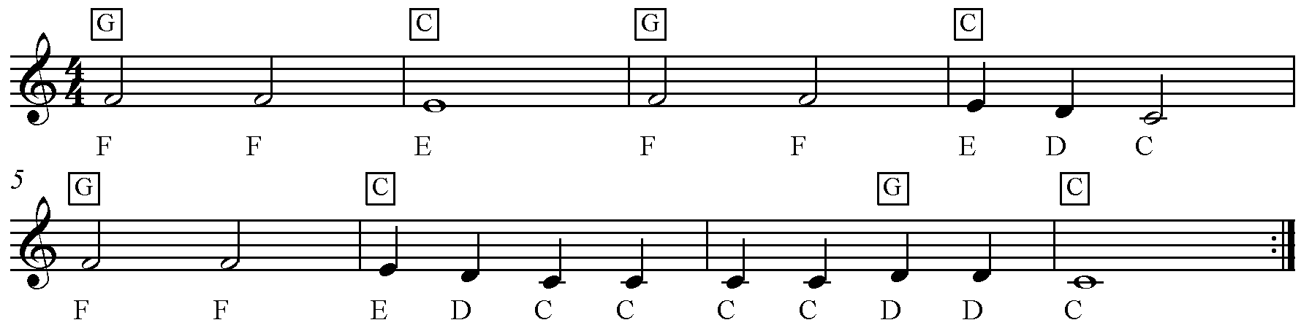

**Stepwise –** moving up or down between notes which are next to each other

**This is a repeat sign**

Merrily We Roll Along

LEVEL 2

38 seconds

Tone – Trumpet

Rhythm – Funk

Tempo - 100

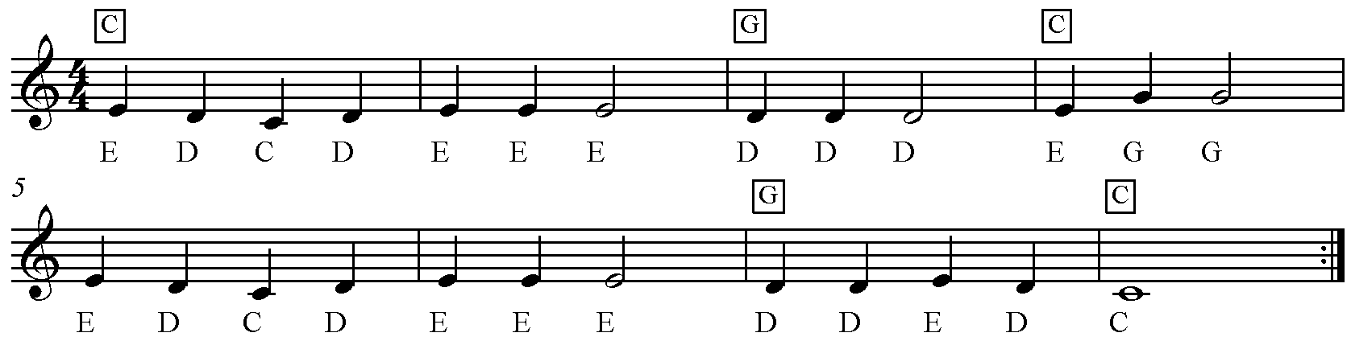

REPETITION – bars 5 & 6 are the same as bars 1 & 2

**This is a repeat sign**

**Repetition –** bars 5 & 6 are the same as bars 1 & 2

STEPWISE – moving between notes which are next to each other

**Stepwise –** moving up or down between notes which are next to each other

**This is a repeat sign**

**Stepwise –** moving up or down between notes which are next to each other

**Repetition –** bars 5 & 6 are the same as bars 1 & 2

**This is a repeat sign**

**Stepwise –** moving up or down between notes which are next to each other

**Repetition –** bars 5 & 6 are the same as bars 1 & 2

Little Bird

LEVEL 2

39 seconds

Tone – Saxophone

Rhythm – Swing

Tempo - 100

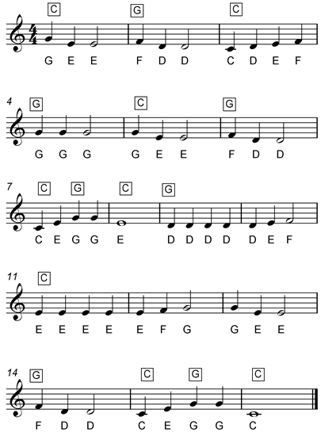

**Sequence** – a pattern of notes repeated at a higher or lower pitch

**Ascending**

Notes which rise in pitch

Love Me Tender

LEVEL 2

20 seconds

Tone – Strings

LEAPING – moving between notes which are not next to each other

Rhythm – Rock/Pop

Tempo - 100



REPETITION – line 2 is the same as line 1

REMEMBER TO LET YOUR TEACHER HEAR YOU PLAY 2 PIECES BEFORE YOU MOVE ON!

LEVEL 3

Monkey Business

LEVEL 3

1 min 20

Tone – Trumpet

Rhythm – Funk

Tempo - 100

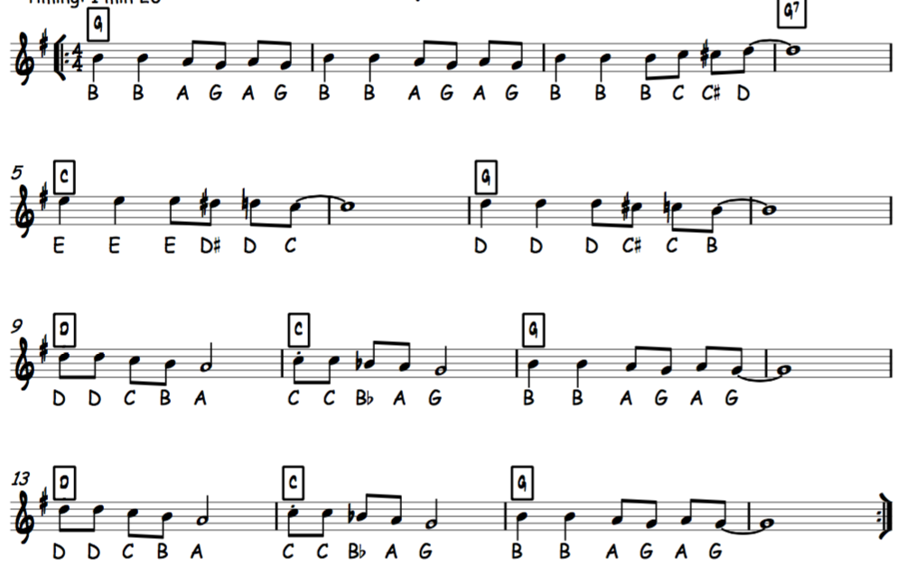

Counting Stars

LEVEL 3

Quaver rest – ½ beat rest

20 seconds

Tone – Clarinet

Rhythm – Ballad

Tempo - 100

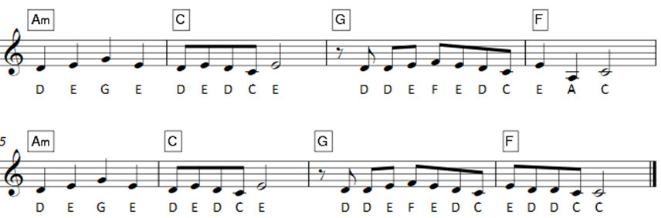

Heathens (21 Pilots)

LEVEL 3

20 secs

Tone – Strings

Rhythm – Rap Rock

Tempo - 80

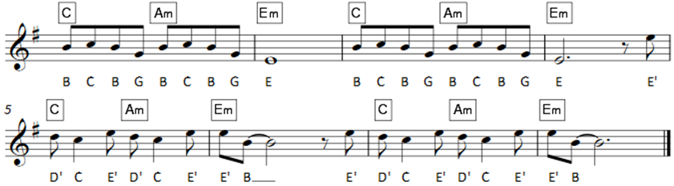

Fight For this Love

LEVEL 3

1min 5

Tie – only play the note once

Tone – Dance Piano

Rhythm – Rap Pop

Tempo - 120

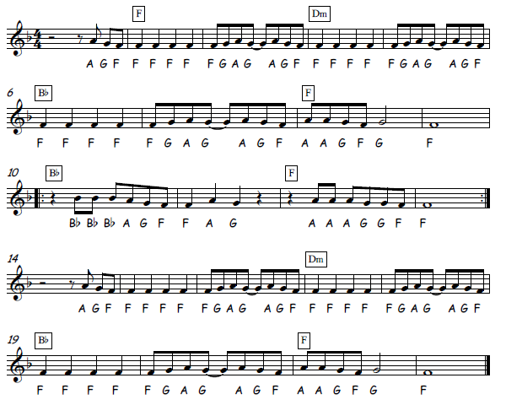

B Flat – the note between A and B

Shape of You

LEVEL 3

30 secs

Tone – Flute

Rhythm – Pop

Tempo - 90

Dotted minim rest – 3 beats rest

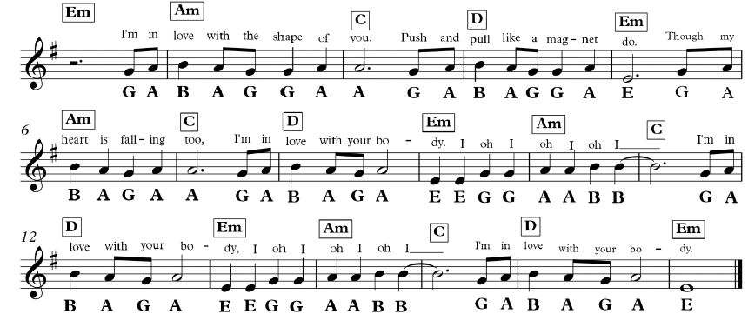

REMEMBER TO LET YOUR TEACHER HEAR YOU PLAY 2 PIECES BEFORE YOU MOVE ON!

LEVEL 4

Yellow

LEVEL 4

1min

Tone – Clarinet

Rhythm – Rock

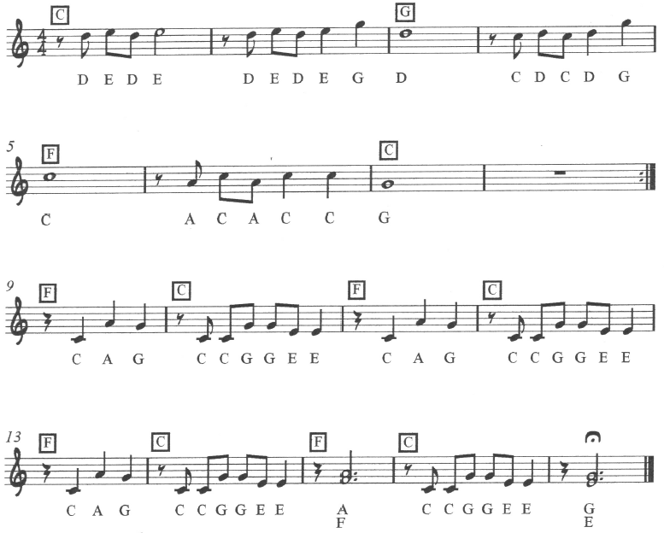Tempo - 85

**Semibreve rest**

This gets 4 beats

**This is a repeat sign**

**Double note – don’t forget to play both!**

Budapest

LEVEL 4

1min

Tone – Soprano Sax

Rhythm – Modern 8 beat

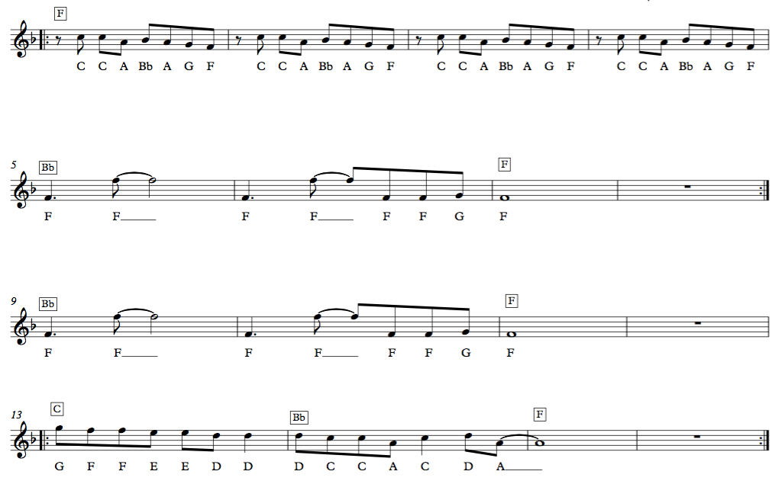Tempo - 100

Mad World

LEVEL 4

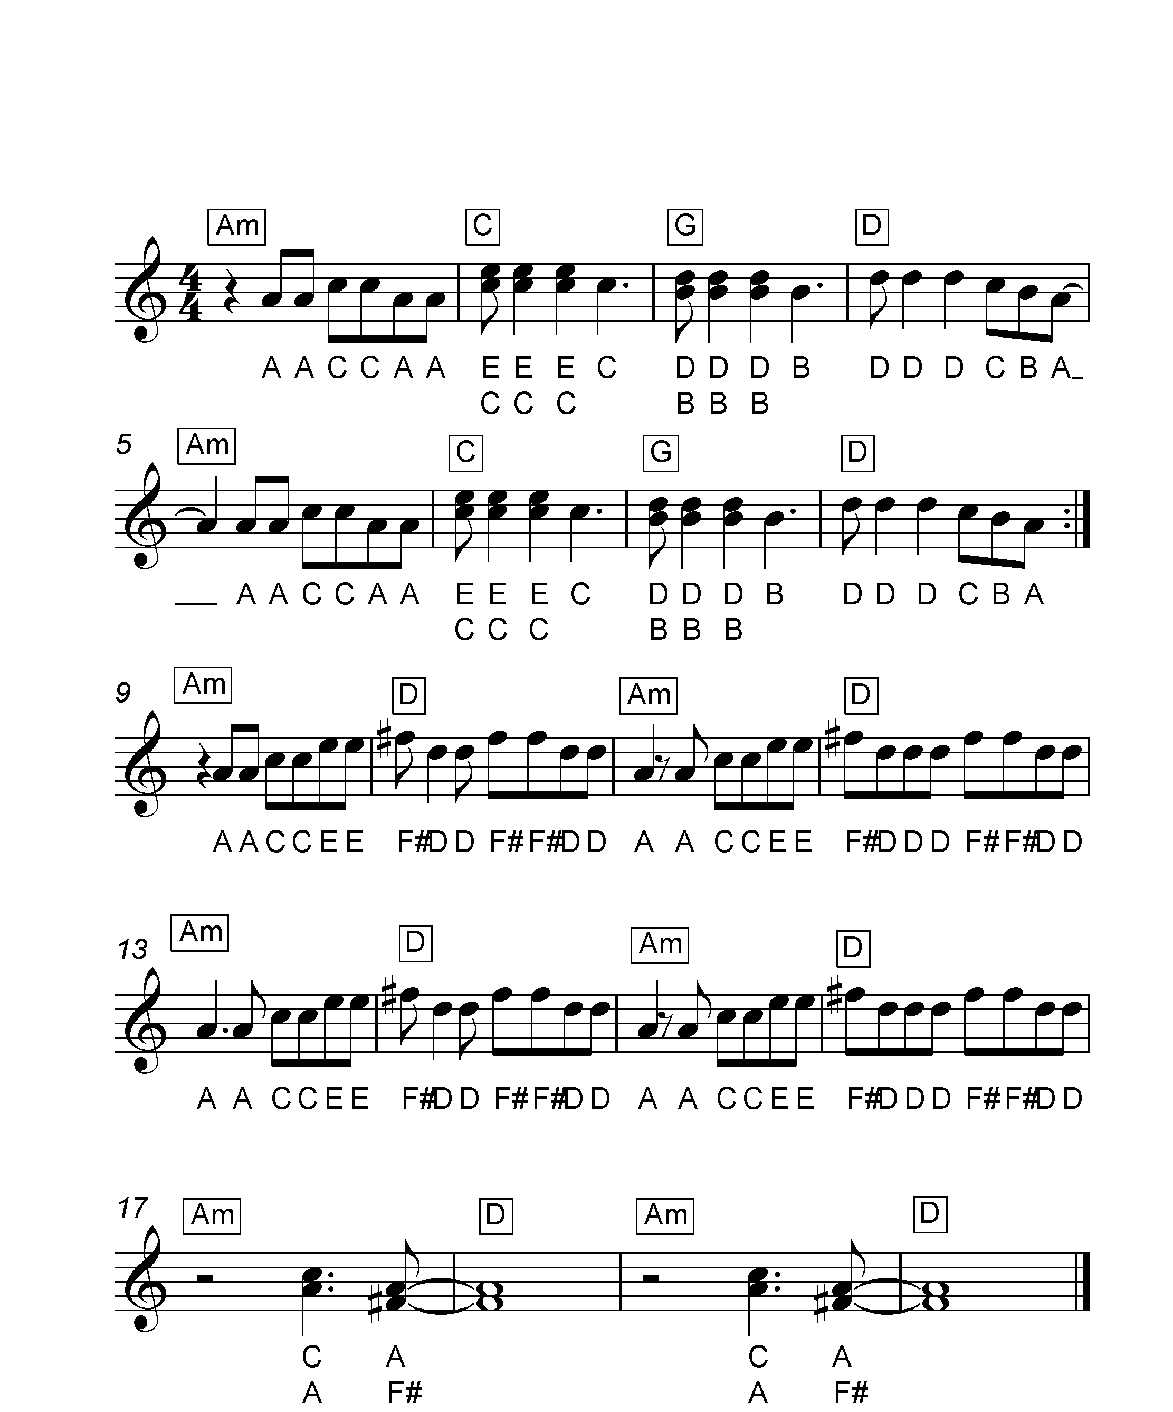1min 5

Tone – Guitar

**Crotchet rest**

This gets 1 beat

Double notes – remember to play both

**This is a repeat sign**

**Minim rest**

This gets 2 beats

Rhythm – Soft Rock

Tempo - 100

Pirates of the Carribean

LEVEL 4

40 secs

Tone – Clarinet

**Sequence** – a pattern of notes repeated at a higher or lower pitch

Rhythm – Rock Waltz

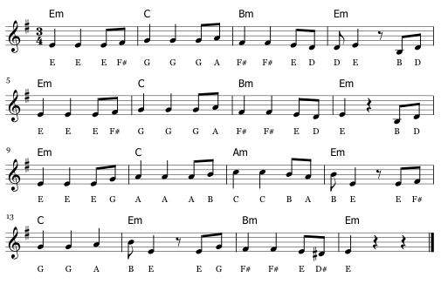Tempo - 110

REPETITION – line 2 is the same as line 1

Ruby

LEVEL 4

Tie – only play the note once

1min 30

Tone – Dist. Guitar

Rhythm – Rock 1

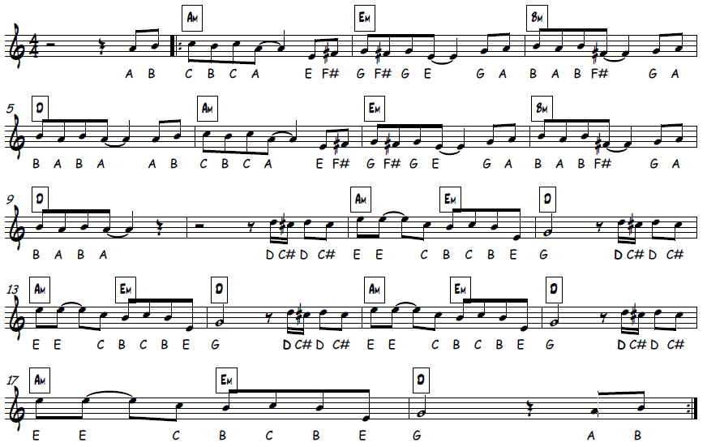Tempo - 90

**This is a repeat sign go to bar 2**

Domino

LEVEL 4

1min 30

**Make sure you check the repeat signs – there are a few!**

Tone – Square Lead

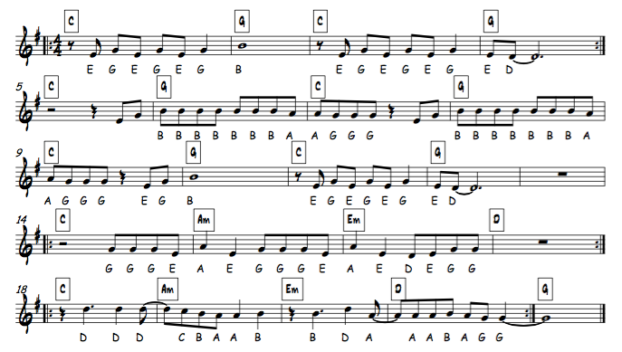Rhythm – Soft rock

Tempo – 115

Slow Rock

LEVEL 4

1 min 50

Tone – Nylon Guitar

Rhythm – 8 beat

Tempo - 100

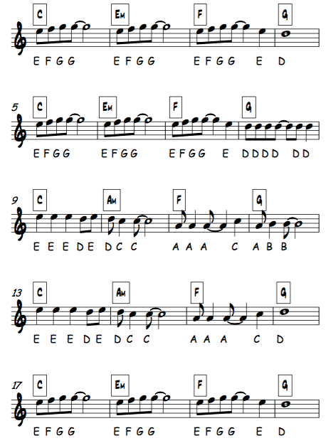

REPETITION – a repeated musical phrase

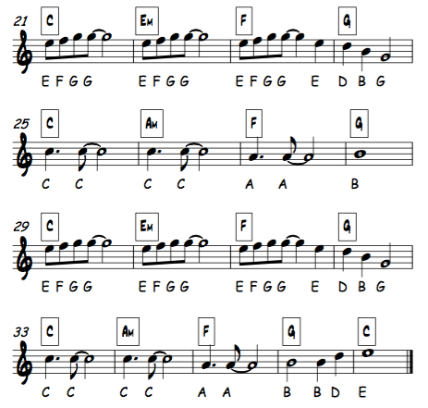

REMEMBER TO LET YOUR TEACHER HEAR YOU PLAY 2 PIECES BEFORE YOU MOVE ON!

LEVEL 5

Little Brown Jug

NATIONAL 5

1 min 5

Tone – Saxophone

Rhythm – Swing

Tempo - 120

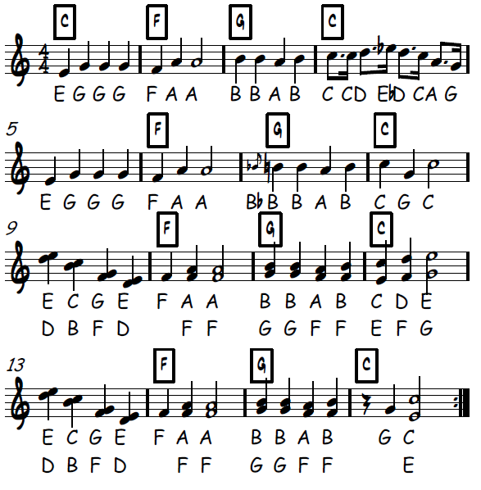

**Grace note – short crushed note before the main note**

**Double notes – remember to play both notes each time!**

Stitches

NATIONAL 5

1 min 40

Tone – Clarinet

Rhythm – Modern Ballad

Tempo - 80

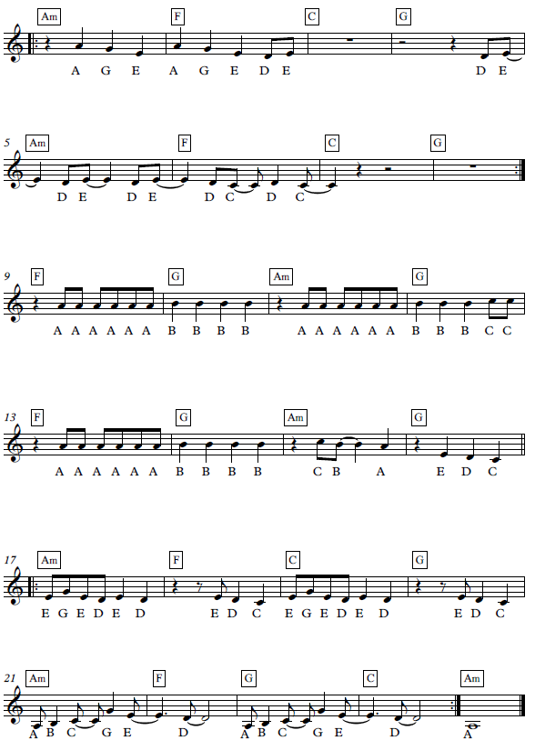

**Repeat from bar 1**

**Repeat from bar 17**

American Patrol

NATIONAL 5

2 min 20

Tone – Alto Sax

**This should be played in a swing style – if you’re not sure, ask your teacher for help!**

Rhythm – Swing

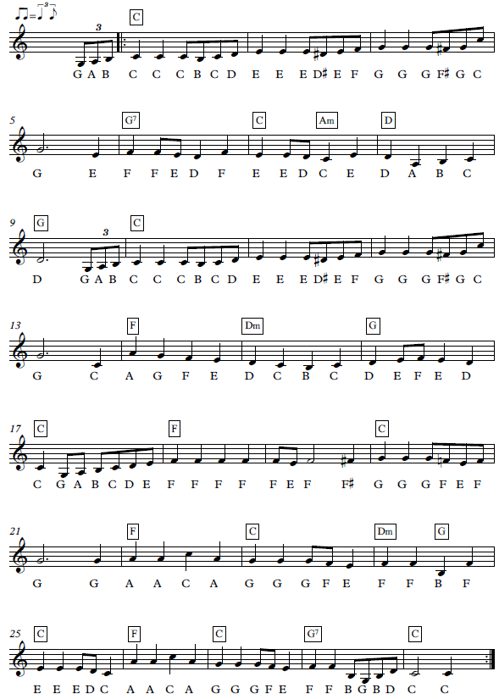Tempo - 120

**Triplet – 3 notes played in the time of 2 (say ‘straw-be-rry)**

Carnival de Paris

**1st & 2nd time bars….first time through you should play the 1st time bar and go back to the start repeat. 2nd time through, go straight to the 2nd time bar**

NATIONAL 5

2 min

Tone – Trumpet

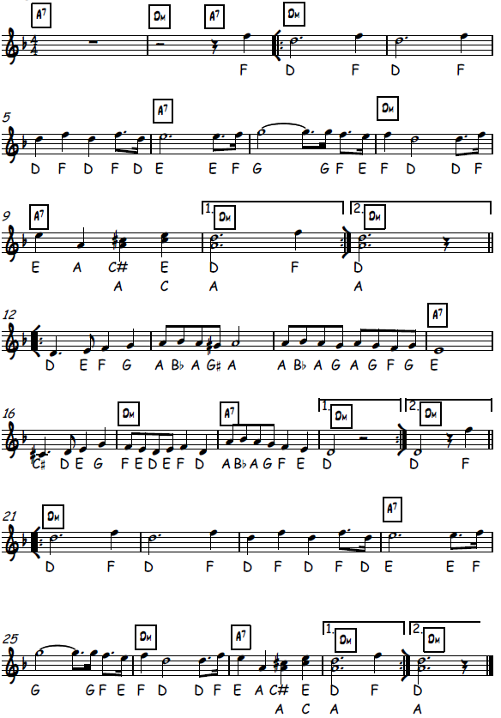Rhythm – Samba

Tempo - 110

Theme From Friends

NATIONAL 5

1 min 50

Tone – Flute

Rhythm – Dance Pop

Tempo - 130

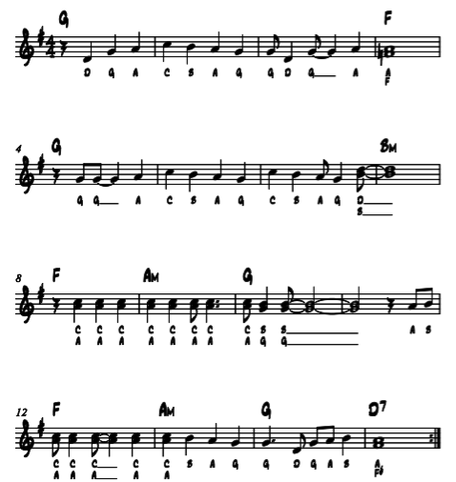

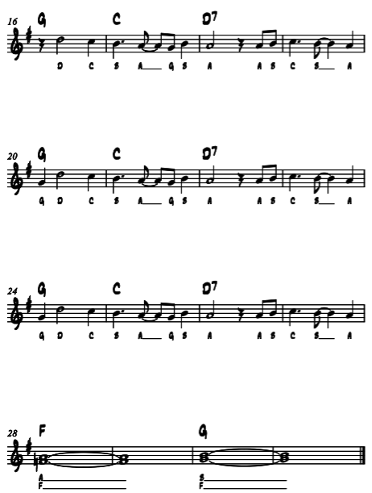

Wrecking Ball

NATIONAL 5

1min 10

Tone – Synth Lead

Rhythm – Trance

Tempo - 100

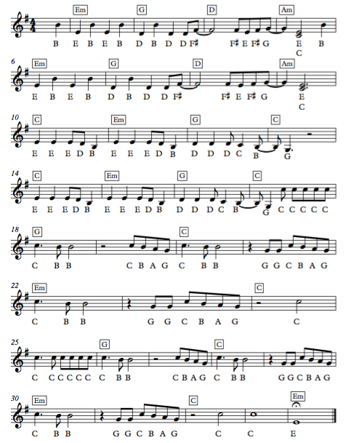

When I’m 64

NATIONAL 5

2min 45

Tone – Clarinet

Rhythm – Ragtime/Jazz

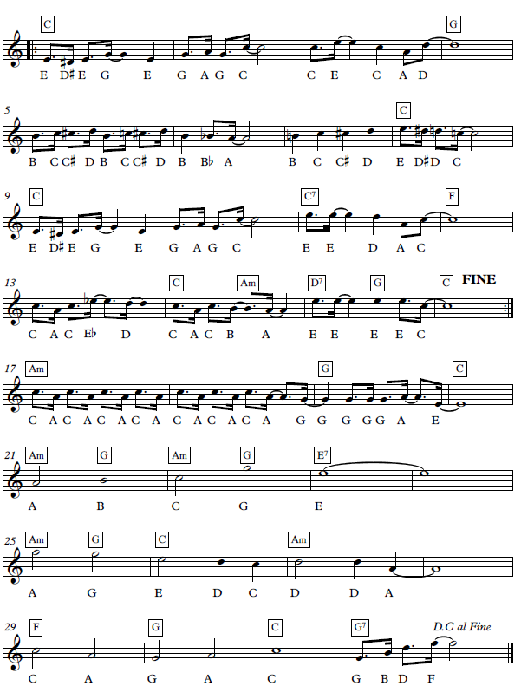Tempo - 120

Bohemian Rhapsody

NATIONAL 5

2 minutes

Tone – Elec Organ

Rhythm – Slow Ballad

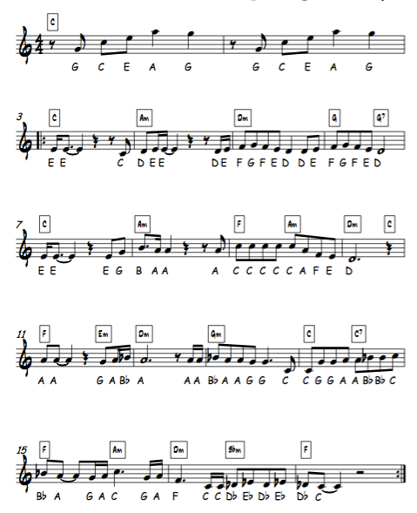Tempo - 70

In Dreams (Lord of the Rings)

NATIONAL 5

2min 45

Tone – Strings

Rhythm – 8 Beat

Tempo – 70

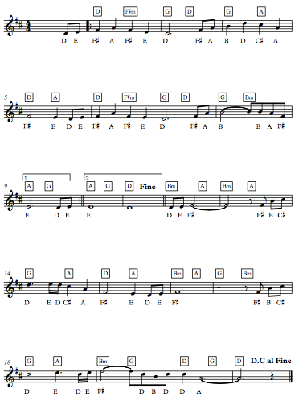

Paradise

NATIONAL 5

1 min 25

Tone – Guitar

Rhythm – Dance Pop

Tempo – 135

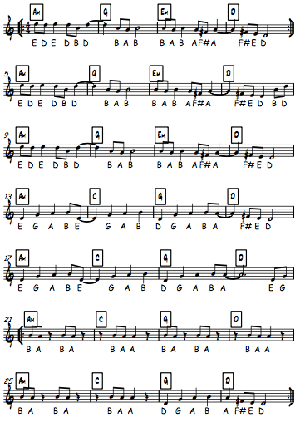

The Rose

NATIONAL 5

1 min 35

Tone – Music Box

Rhythm – Slow Ballad

Tempo – 70

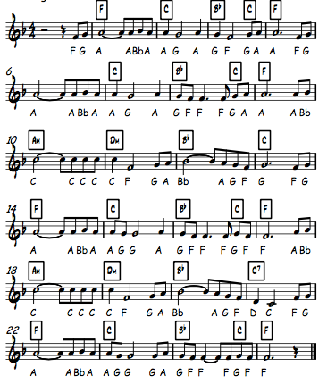

Tetris

NATIONAL 5

1 minute

Tone – Square Lead

Rhythm – Trance

Tempo – 120

