ARDROSSAN ACADEMY

MUSIC DEPARTMENT
PERFORMING
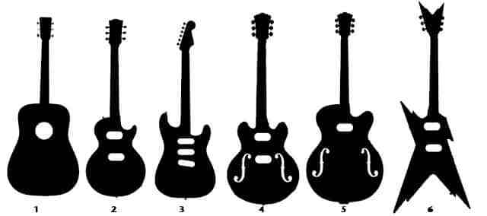

LEVEL 2 – NATIONAL 5
CHORDAL GUITAR
MUSIC COURSE

Requirements
Bronze
I can play the melody and rhythms with some accuracy, using 2 beaters. I can follow the music notation and understand where the notes are in relation to the stave. I might have to stop in my performance to check notes and rhythms.

Silver
I can play the melody and rhythms accurately most of the time, using 2 beaters, and can understand most of the information on notes and rhythms given in the notation. I might have to slow down to help get through difficult sections of music.

Gold
I can play the melody and rhythms accurately and understand how these relate to the music notation. The music flows throughout. I have some understanding of the music symbols in the notation, including accidentals and dynamics.

I will know I am successful when I can:
- Hold the guitar and strum correctly
- Make a clear sound
- Understand how to read chord boxes and guitar TAB
- Play the correct chords/melody and rhythm
- Play with a melody or accompaniment

You should ensure you check the requirements of each level in the contents section to fully understand what is required for assessment.

CONTENTS
LEVEL 2
3 chords - strumming only
Chords 1 – Twinkle Twinkle
Chords 2 – Pencil full of Lead
Melody 1 – Merrily
Melody 2 – Twinkle Twinkle
Melody 3 – Love me Tender
ASSESSMENT - You should play 1 chordal song and 1 melody to your teacher to secure this level

LEVEL 3
6 chords - strumming only
Chords 1 – Shape of You
Chords 2 – Heathens
Chords 3 – We Are Never Getting Back Together
Chords 4 – Mad World
Chords 5 – Forget You
Chords 6 – Scotland the Brave
Melody 1 – Seven Nation Army
Melody 2 – This Old Man
Melody 3 – Smoke on the Water
ASSESSMENT - You should play 2 chord songs and 1 melody to your teacher to secure this level

LEVEL 4/NATIONAL 4
9 chords - strumming & arpeggios
Chords 1 – Somewhere Only We Know
Chords 2 – Stitches
Chords 3 – Little Brown Jug
Chords 4 – Hallelujah (MUST show example of arpeggios)
Chords 5 – 7 Years
Melody 1 – Loch Lomond
Melody 2 – Every Breath You Take
Melody 3 – Spanish Song
ASSESSMENT - You should play 2 chordal songs (one with arpeggios), ensuring you play 9 chords as part of that programme and 1 melody to your teacher to secure this level

NATIONAL 5
12 chords
more advanced strumming/arpeggios & barre chords

Chord 1 – Don’t Look Back in Anger
Chord 2 – Half the World Away
Chord 3 – Fields of Gold
Chord 4 – Imagine
Chord 5 – Ruby
Chord 6 – Rollin’ in the Deep
Chord 7 – It’s All About You
Melody 1 – In the Hall
Melody 2 – Jazz Breakdown
Melody 3 – Pretty Woman
Melody 4 – Wonderful Tonight

ASSESSMENT
CHORDS - As part of the National 5 programme you are required to play 12 chords across AT LEAST 2 contrasting songs – you can choose songs from across the levels, however you must ensure you meet the minimum number of chords. You should also demonstrate arpeggios in at least one of your pieces. You may find music from other sources, however the melody line and chords must be available to the examiner.
MELODY – You are required to play level specific material (NATIONAL 5 standard). You may find material from other sources, such as Rock School or Trinity books
STRUMMING PATTERNS
D = Down
U = Up
These are only suggested
strumming patterns – feel
free to try your own.
(As long as it fits with the style
of the music)

LEVEL 2

Use the chord boxes to show you where to put your fingers. Below is a picture of the chord of C. Try to relate this to the chord box above.
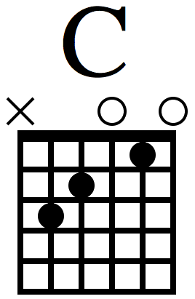
X – don’t play that string
O – play the string open, with no frets
The black dots represent your fingers – make sure they are pressed hard against the backboard
The strings are the vertical lines on the diagram. The string on the left is low E, the thickest string on the guitar (the one closest to you when you are holding the guitar).

Fret 1
Fret 2
Fret 3
Fret 4
Fret 5

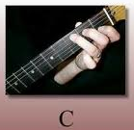
- Numbers tell you where to put each finger.
- A cross (x) means do not play that string.
- A ‘O’ means an open string – no fingers on it.

The 3 chords you should learn for this level are:
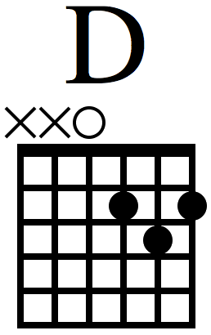
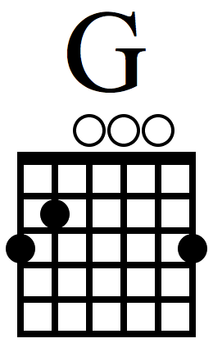

CHORD 1 - Twinkle Twinkle
LEVEL 2
25 secs
STRUMMING PATTERN – DDU U DDU
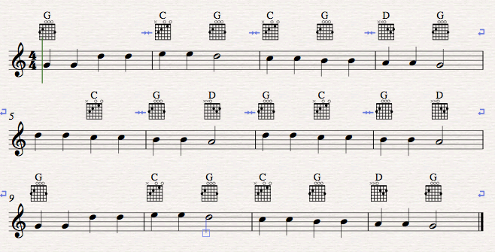

This is a repeat sign
Repetition – bars 5 & 6 are the same as bars 1 & 2
This is a repeat sign
Repetition – bars 5 & 6 are the same as bars 1 & 2

CHORD 2 - Pencil Full of Lead
LEVEL 2
20 secs
STRUMING PATTERN – DUD DUD
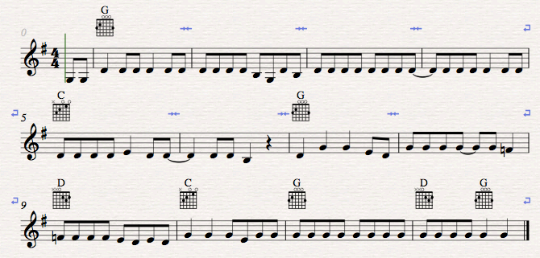

Guitar TAB (MELODY)

Guitar TAB is 6 lines with each line representing a different string. The top line is the thinnest string (the one closest to the ground) and the bottom line is the thickest string (the one closest to the roof).

Thinnest - 1st --------------------------------
2nd --------------------------------
STRINGS 3rd ---------------------------------
4th ---------------------------------
5th ---------------------------------
Thickest - 6th --------------------------------

A number on a line, tells you what fret to put your finger on e.g. 0 means no frets, 1 means 1st fret, 4 means 4th fret etc.

1st Fret
2nd Fret
3rd Fret
4th Fret
5th Fret

Before you play the note, make sure you have checked these things:

What string is the number on?
Remember: top line = bottom string.
What fret have you to play?
Make sure both of your hands match up on the same string.
Press the fret really hard.
Don’t use the same finger for every fret!
1st finger = 1st Fret, 2nd Finger = 2nd Fret,
3rd Finger = 3rd Fret
Practice your piece lots of times; making sure it is fluent before asking your teacher to assess you.
If notes have a tail or are joined together then play them faster (quavers – ½ beat).

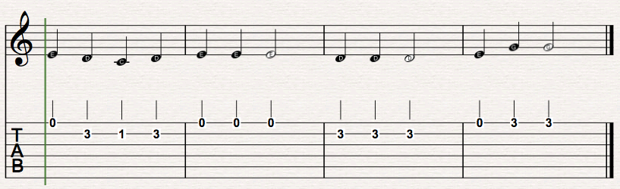
MELODY 1 - Merrily

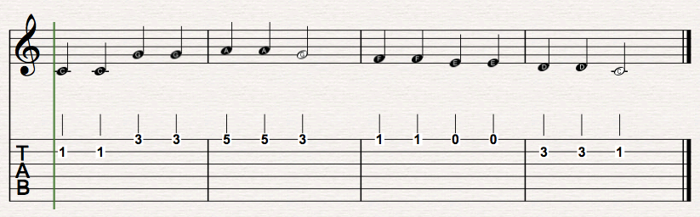
MELODY 2 – Twinkle Twinkle

MELODY 3 – LOVE ME TENDER
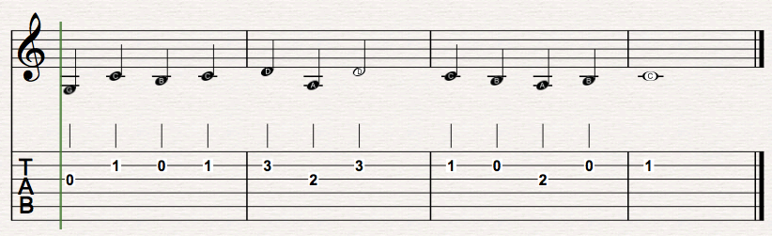

REMEMBER TO LET YOUR TEACHER HEAR YOU PLAY 1 CHORDAL PIECE & 1 MELODY BEFORE YOU MOVE ON!

LEVEL 3

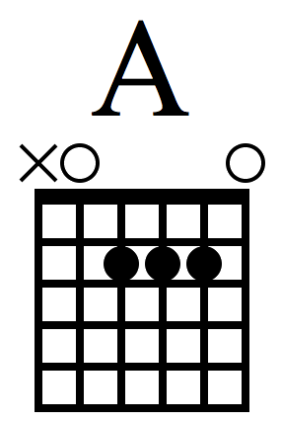
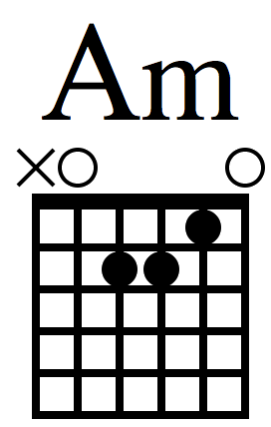
You should learn the 3 chords from level 2 and the following 3 chords:
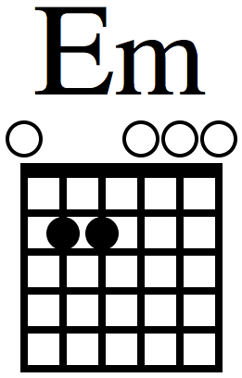

CHOOSE ONE CHORDAL SONG FROM 1 -4 AND ONE FROM 5-6

CHORD 1 - Shape of You
LEVEL 3
30 secs
Strumming Pattern – D D U
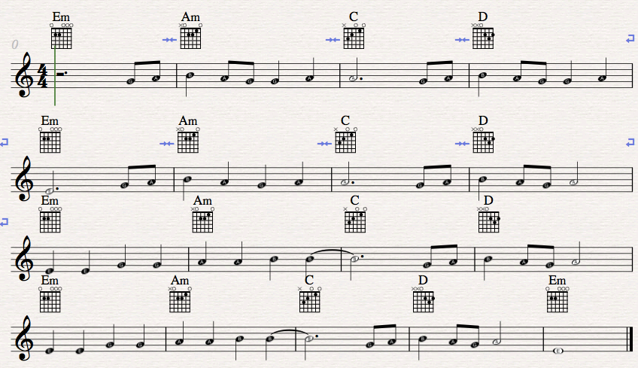

CHORD 2 - Heathens
LEVEL 3
20 secs
Strumming Pattern – D U D U
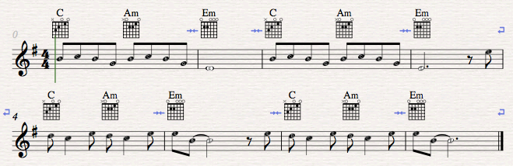

CHORD 3 – We are Never
Getting Back Together
LEVEL 3
25 secs
STRUMMING PATTERN – D D D D

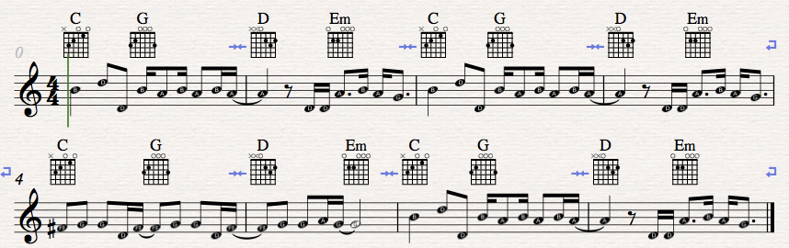

CHORD 4 - Mad World
LEVEL 3
1min 5
STRUMMING PATTERN – DUD DUD
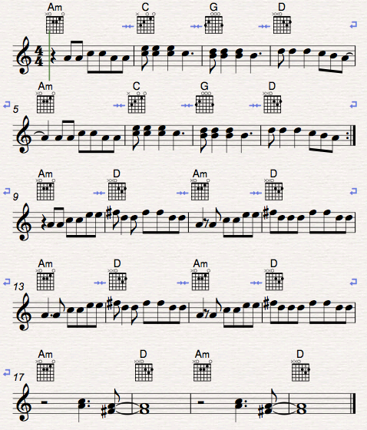

CHORD 5 – FORGET YOU
LEVEL 3
30 seconds
STRUMMING PATTERN – D DUD D DUD
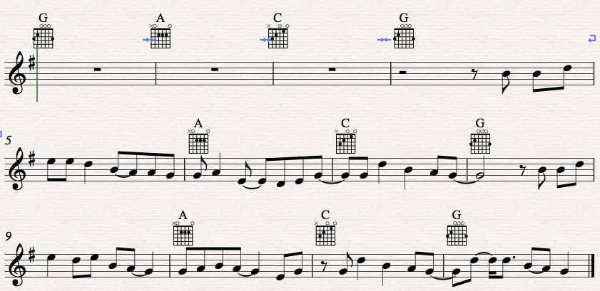

CHORD 6 – SCOTLAND THE BRAVE
LEVEL 3
30 seconds
STRUMMING PATTERN – D DUDUD D DUDUD

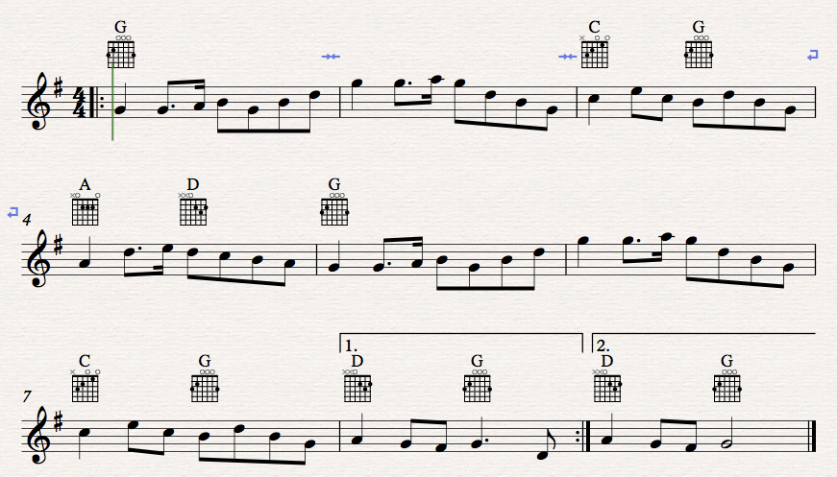

MELODY 1
This is a TRIPLET – play 3 even notes in the space of 2. Rhythm should sound like the word STRAW-BERR-Y.
Repeat line
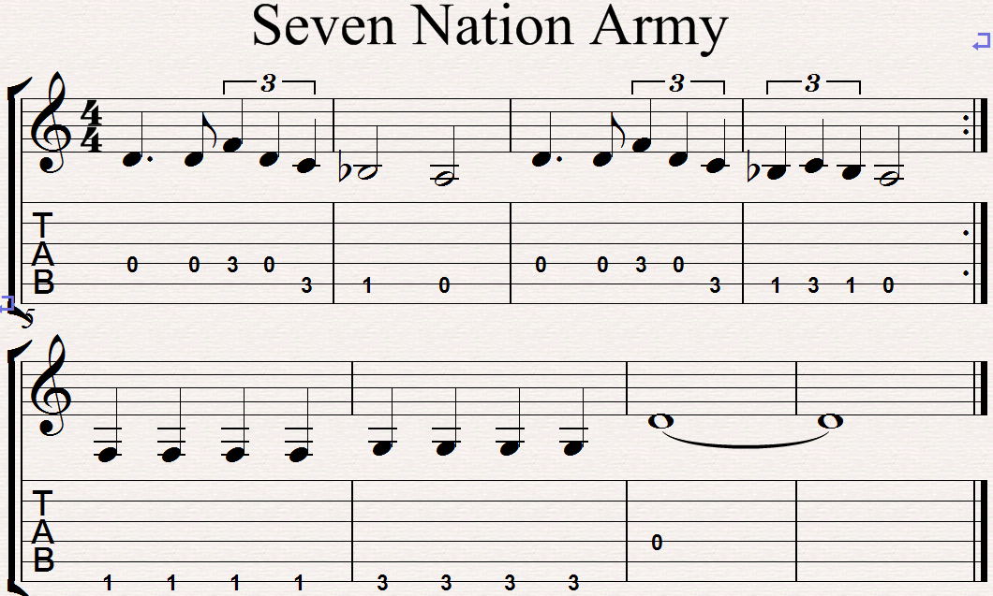

REMEMBER TO LET YOUR TEACHER HEAR YOU PLAY 2 PIECES & 1 RIFF BEFORE YOU MOVE ON!
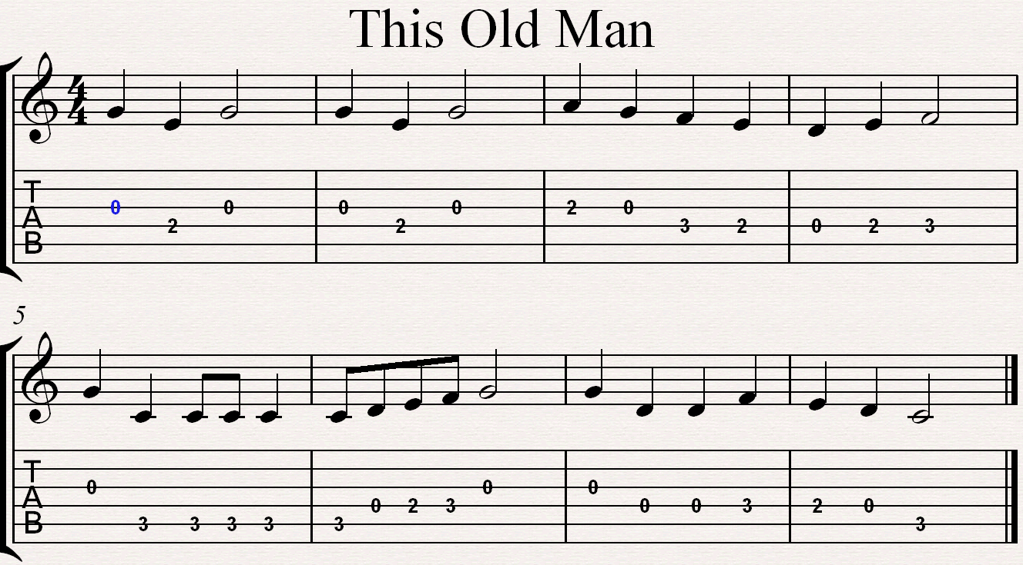
MELODY 2
Practice this bit lots of times until you can play it quickly and fluently.

MELODY 3
Pattern 1

Same pattern as above but down a string

Back to pattern 1

REMEMBER TO LET YOUR TEACHER HEAR YOU PLAY 1 CHORDAL PIECE FROM 1-4, ONE FROM 5-6 & 1 MELODY BEFORE YOU MOVE ON!

LEVEL 4 / NATIONAL 4

You should learn the 6 chords from levels 2 and 3 and the following 3 chords:
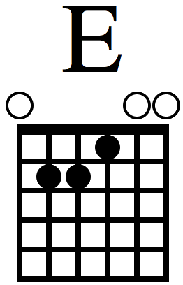
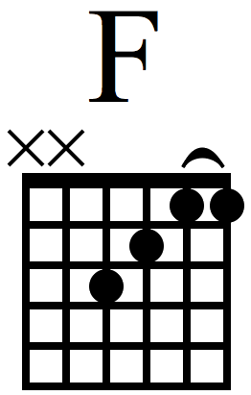
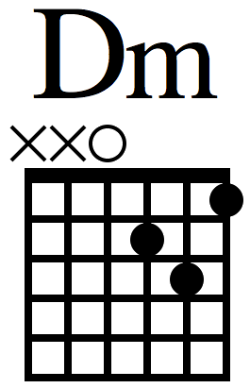

Make sure the 2 pieces you choose to play to your teacher show all 9 chords! (You may play one song from LEVEL 3)
CHORD 1 - Somewhere only we know
LEVEL 4/NAT 4
1 minute
STRUMMING PATTERN - DUDUDUDU

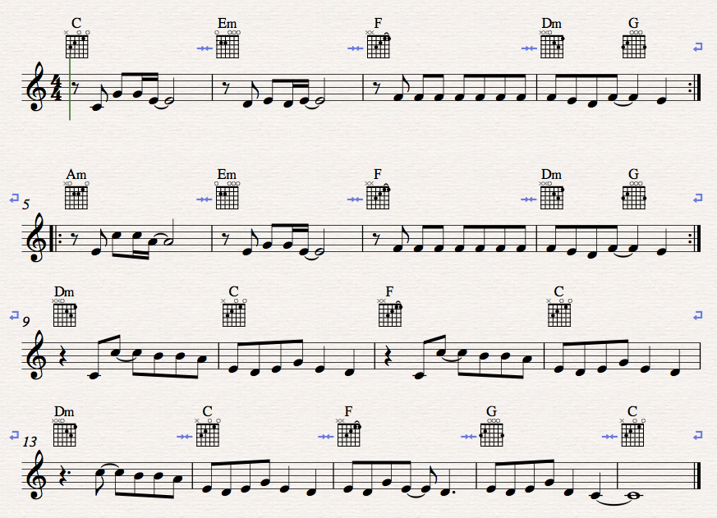

CHORD 2 - STITCHES
LEVEL 4/NAT 4
1 min 40
STRUMMING PATTERN
1st 16 BARS – D U U U U
LAST 8 BARS – DUDU U U

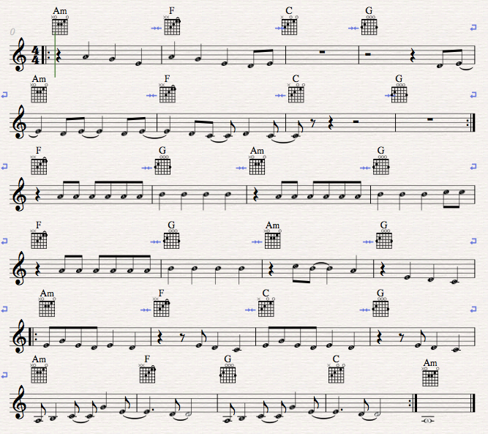

CHORD 3 - Little Brown Jug
LEVEL 4/NAT 4
1 min 5

STRUMMING PATTERN – Jazzy!

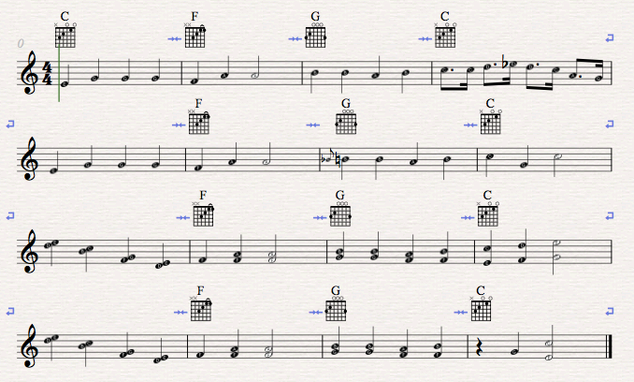

CHORD 4 – Hallelujah
LEVEL 4/NAT 4
1 min 5
USE ARPEGGIO STYLE ACCOMPANIMENT
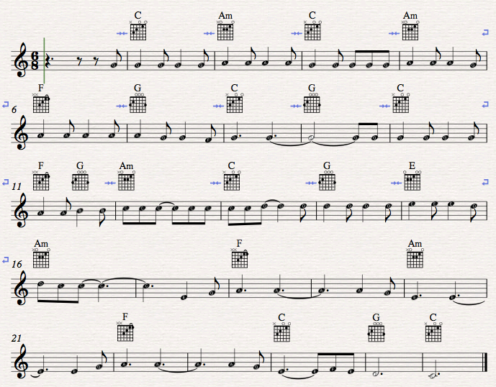

CHORD 5 – 7 Years
LEVEL 4/NAT 4
1 min 20
BARS 1-6 – Arpeggio style then chords
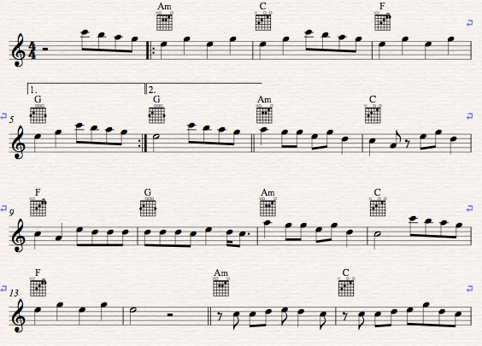

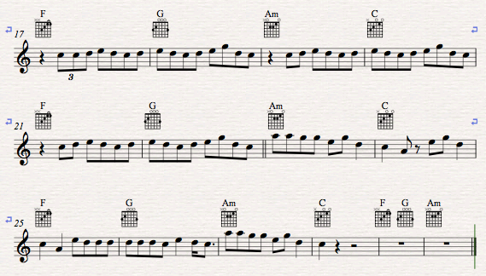

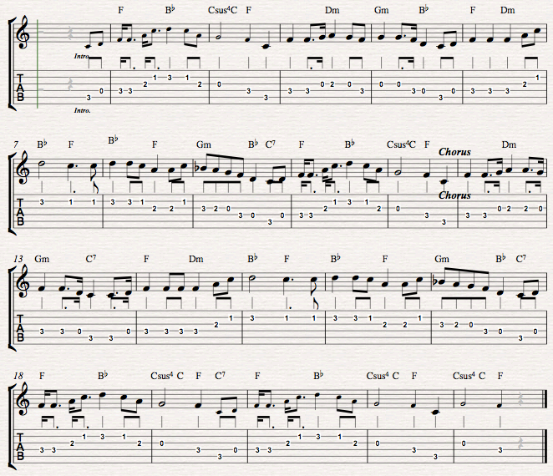
MELODY 1 – Loch Lomond

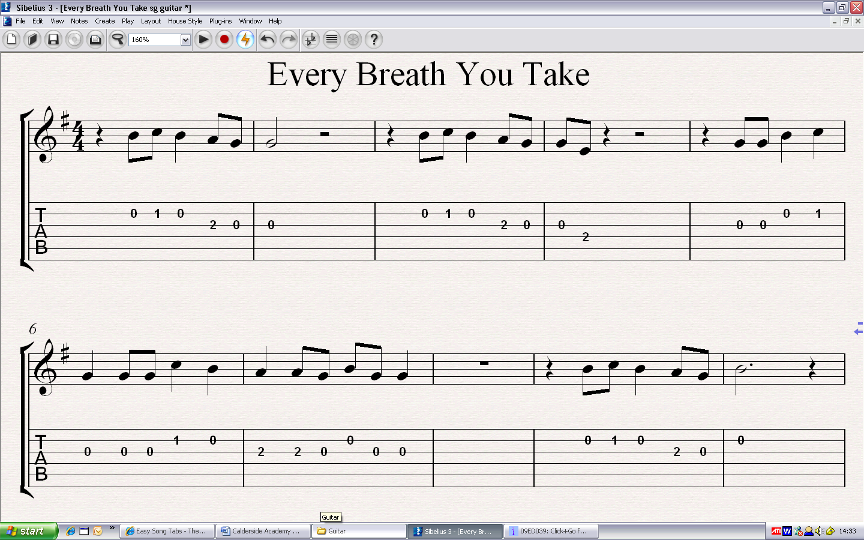
MELODY 2

MELODY 3 – SPANISH SONG
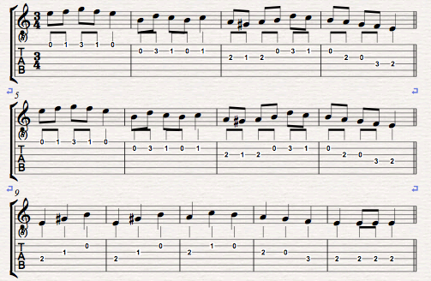

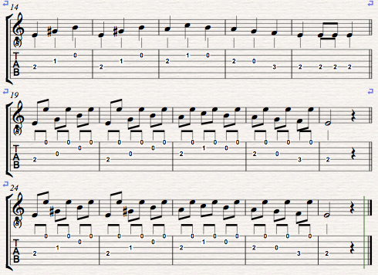

REMEMBER TO LET YOUR TEACHER HEAR YOU PLAY 2 CHORD PIECES (min. 9 chords and an example of arpeggios), & 1 MELODY PIECE BEFORE YOU MOVE ON!

NATIONAL 5

In this section there are a range of songs using lots of different chords. Choose carefully, making sure you have at least 12 chords, including barre chords and show examples of different strumming techniques & arpeggios.
NOT ALL CHORDS ARE IN THIS BOOKLET – USE A SEARCH ENGINE ON THE INTERNET TO FIND CHORDS YOU DON’T KNOW.
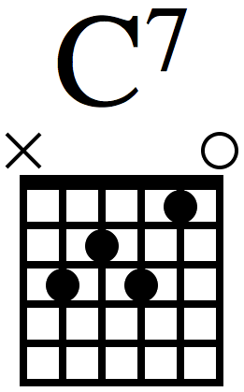
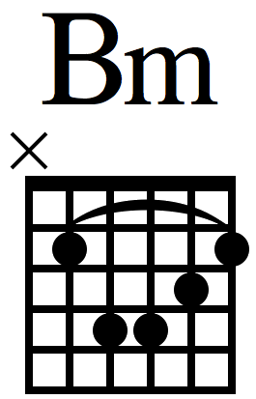
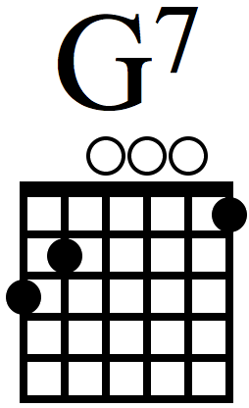
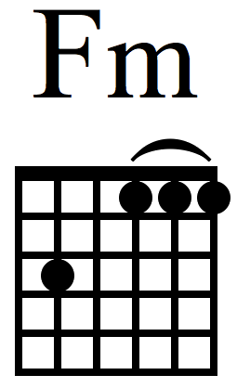
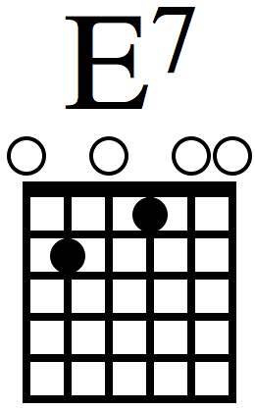

For assessment you can decide whether you will play a chord programme or melody programme

CHORD 1 - DON’T LOOK BACK IN ANGER
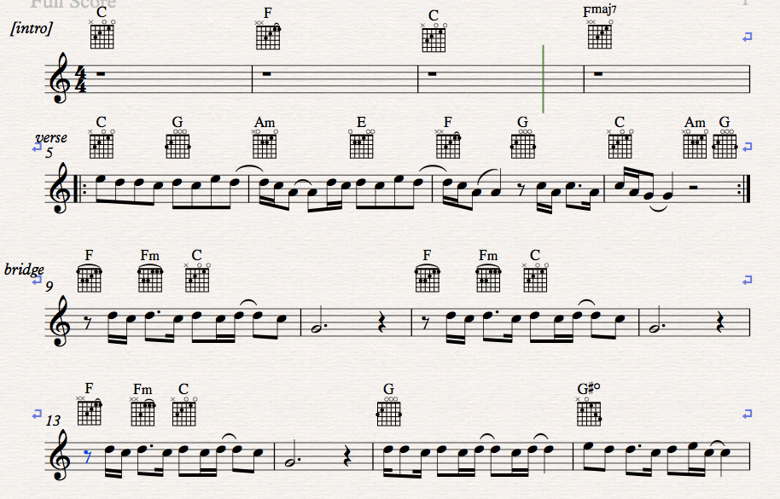
NATIONAL 5
1 MINUTE 40

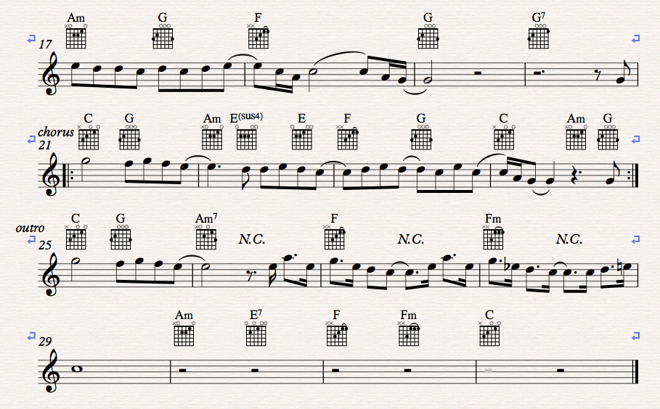

CHORD 2 – HALF THE WORLD AWAY
NATIONAL 5
3 MIN 10
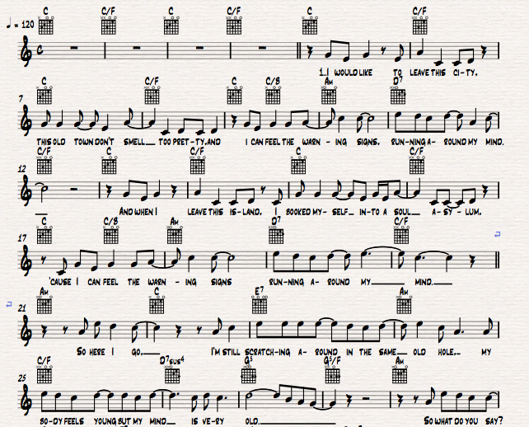

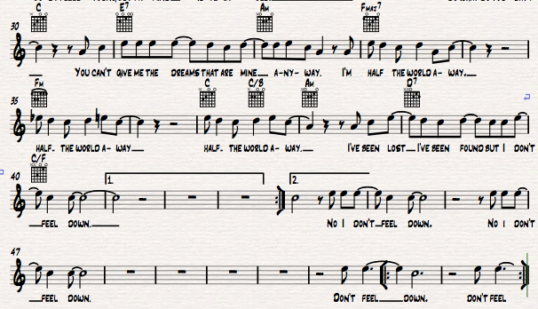

CHORD 3 – FIELDS OF GOLD
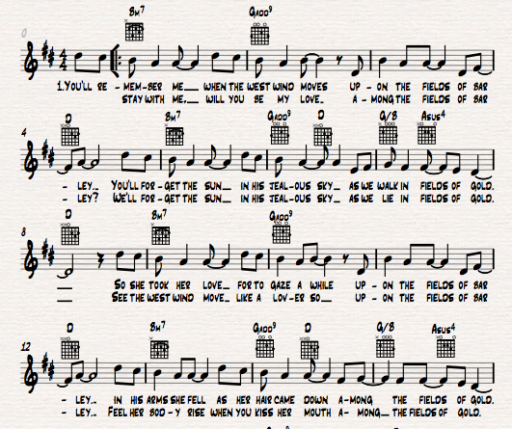
NATIONAL 5
1 MINUTE 40

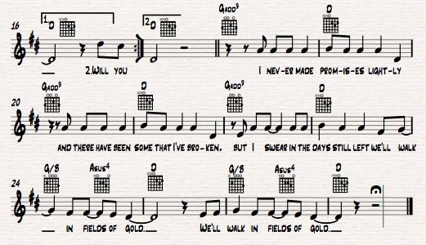

CHORD 4 – IMAGINE
NATIONAL 5
1 MIN 20
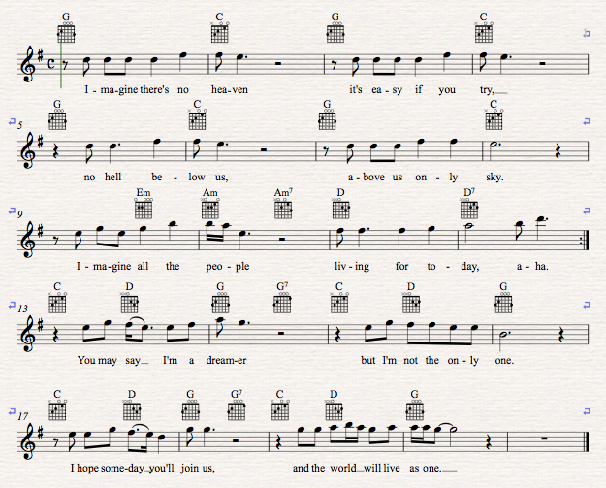

CHORD 5 - Ruby
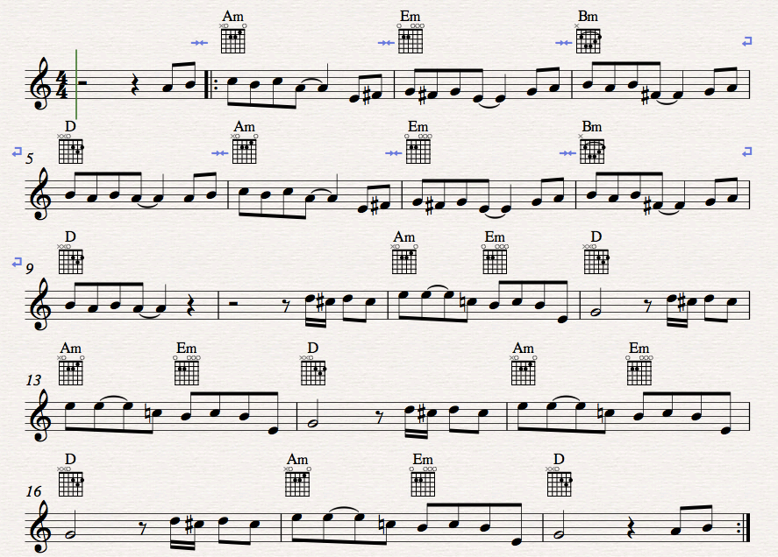
NATIONAL 5
1min 30

CHORD 6 – Rollin’ in the Deep
NATIONAL 5
1min 20
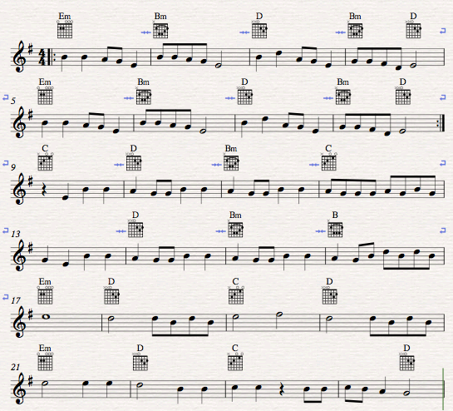

CHORD 7 – It’s All About You
NATIONAL 5
3 minutes 25
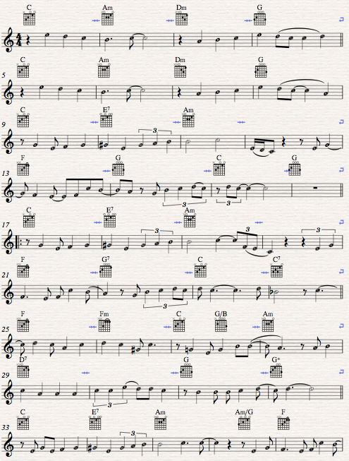

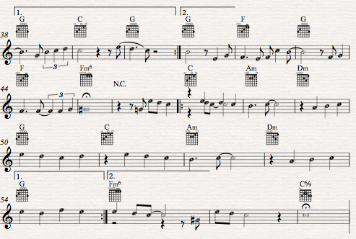

MELODY 1 – In The Hall
NATIONAL 5
1min
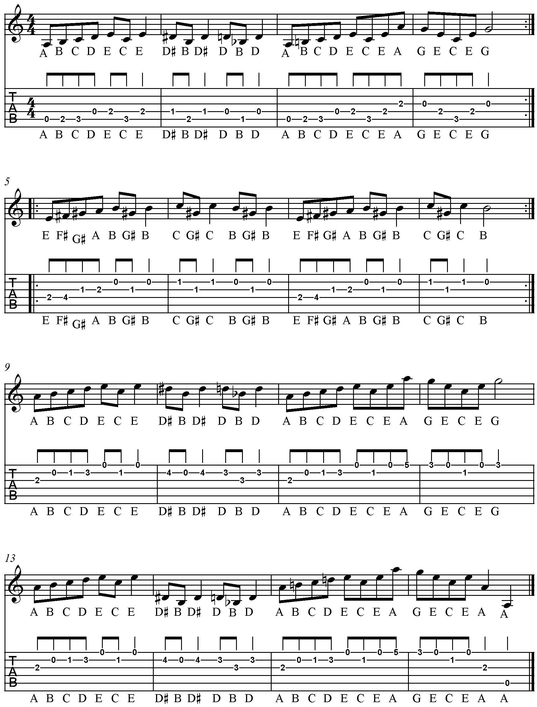
A
Ternary Form
A B A – 3 part form: Section A, followed by a B section which is a different melody, than a return to the A section.

This is a repeat sign

B

A

MELODY 2 – Jazz Breakdown
NATIONAL 5
1min
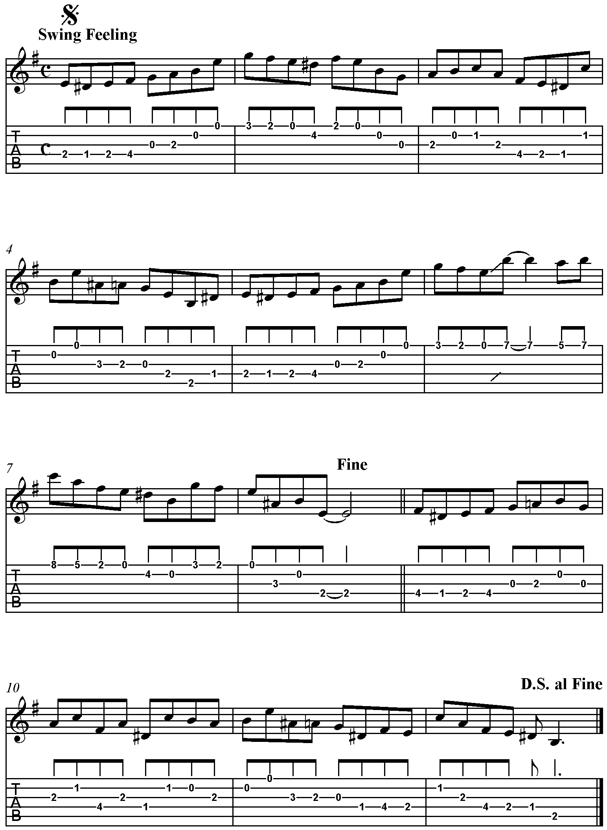
MELODY 3 – Pretty Woman
NATIONAL 5
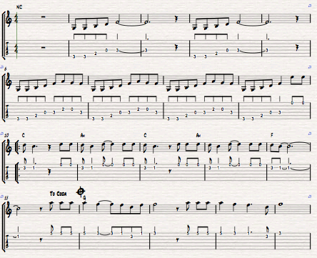
4min

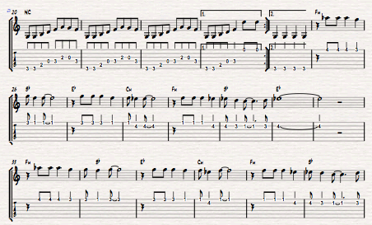

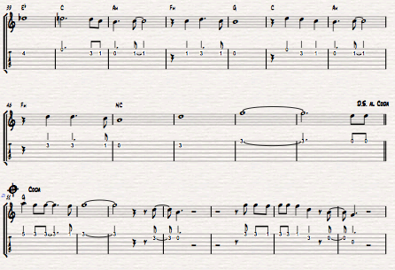

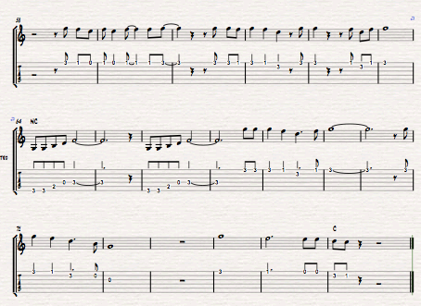

MELODY 4 – Wonderful Tonight
NATIONAL 5
2min 40
