ARDROSSAN ACADEMY

MUSIC DEPARTMENT

PERFORMING

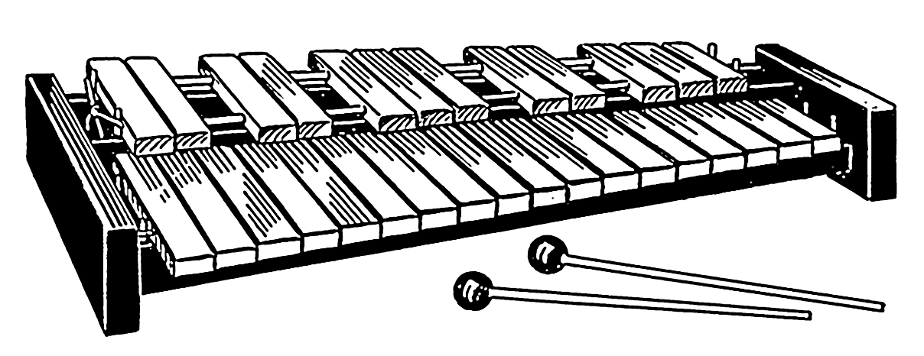

LEVEL 2 – NATIONAL 5

GLOCKENSPIEL

MUSIC COURSE



**Requirements**

**Bronze**

I can play the melody and rhythms with some accuracy, using 2 beaters. I can follow the music notation and understand where the notes are in relation to the stave. I might have to stop in my performance to check notes and rhythms.

**Silver**

I can play the melody and rhythms accurately most of the time, using 2 beaters, and can understand most of the information on notes and rhythms given in the notation. I might have to slow down to help get through difficult sections of music.

**Gold**

I can play the melody and rhythms accurately and understand how these relate to the music notation. The music flows throughout. I have some understanding of the music symbols in the notation, including accidentals and dynamics.

**I will know I am successful when I can:**

* Hold the beaters correctly
* Make a clear sound
* Play the melody notes accurately with my right hand only
* Play the correct rhythm
* Play with an accompaniment

**You should complete 2 pieces of music at each level and perform them for your teacher before moving on.**

CONTENTS

LEVEL 2

Bye Bye Love (38 secs)

Merrily We Roll Along (38 secs)

Little Bird (39 secs)

Love Me Tender (20 secs)

LEVEL 3

Counting Stars (20 secs)

Fight For this Love (1min 5)

Heathens (21 Pilots) (20 secs)

Shape of You (30 secs)

LEVEL 4/NATIONAL 4

Yellow (1min)

Mad World (1min 5)

Pirates of the Caribbean (40 secs)

Ruby (1min 30)

Highland Waltz (2 mins)

NATIONAL 5

Little Brown Jug (1min 5)

Stitches (1min 40)

American Patrol (2min 20)

Carnival de Paris (2min)

Match of the Day (1min 55)

When I’m 64 (2min 45)

In the Hall (1min)

Over the Rainbow (1min 30)

Don’t you want me (2 mins)

Somebody that I used to know (1min 40)

Tetris (1min)

LEVEL 2

Bye Bye Love

LEVEL 2

**Semibreve – this note gets 4 beats**

**Minim – this note gets 2 beats**

38 seconds

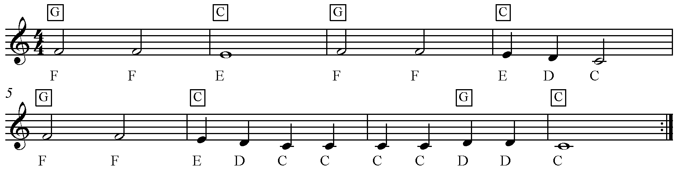

**Stepwise –** moving up or down between notes which are next to each other

**This is a repeat sign**

Merrily We Roll Along

LEVEL 2

38 seconds

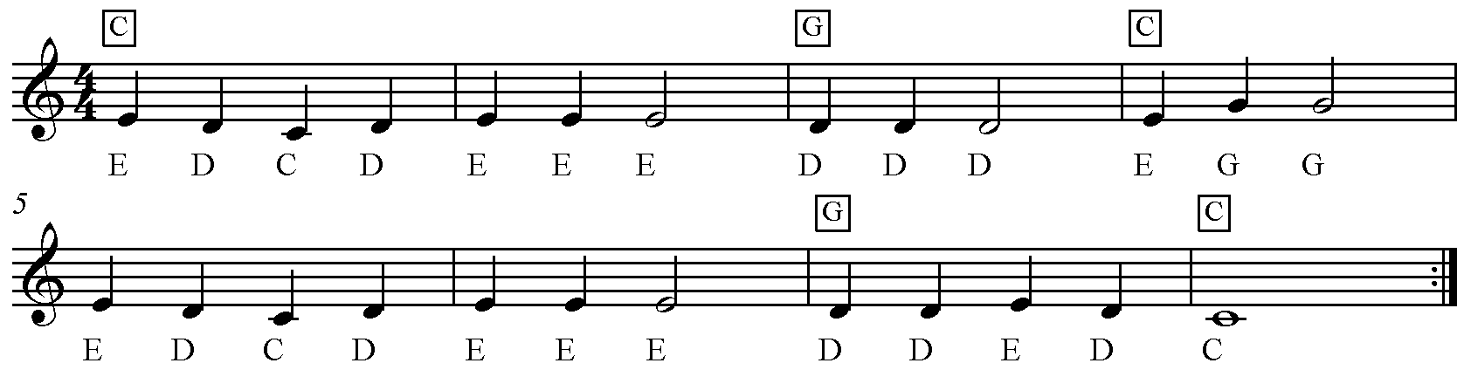

REPETITION – bars 5 & 6 are the same as bars 1 & 2

**This is a repeat sign**

**Repetition –** bars 5 & 6 are the same as bars 1 & 2

STEPWISE – moving between notes which are next to each other

**Stepwise –** moving up or down between notes which are next to each other

**This is a repeat sign**

**Stepwise –** moving up or down between notes which are next to each other

**Repetition –** bars 5 & 6 are the same as bars 1 & 2

**This is a repeat sign**

**Stepwise –** moving up or down between notes which are next to each other

**Repetition –** bars 5 & 6 are the same as bars 1 & 2

Little Bird

LEVEL 2

39 seconds

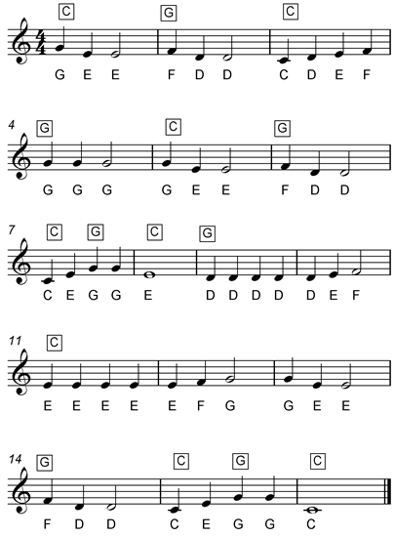

**Sequence** – a pattern of notes repeated at a higher or lower pitch

**Ascending**

Notes which rise in pitch

Love Me Tender

LEVEL 2

20 seconds

LEAPING – moving between notes which are not next to each other



REPETITION – line 2 is the same as line 1

REMEMBER TO LET YOUR TEACHER HEAR YOU PLAY 2 PIECES BEFORE YOU MOVE ON!

LEVEL 3

Counting Stars

LEVEL 3

Quaver rest – ½ beat rest

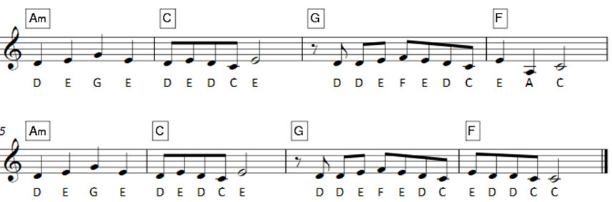20 seconds

Fight For this Love

LEVEL 3

1min 5

Tie – only play the note once

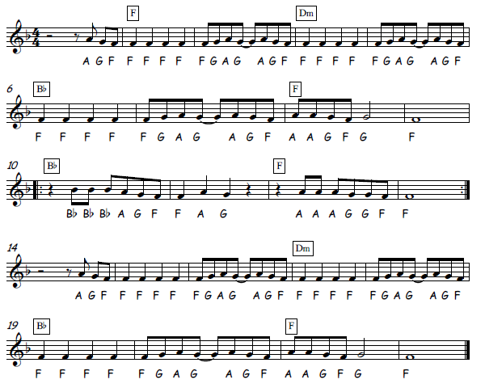

B Flat – the note between A and B

Heathens (21 Pilots)

LEVEL 3

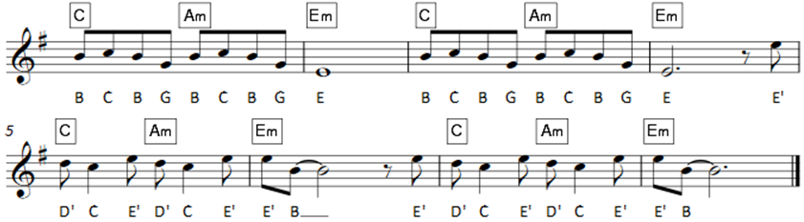20 secs

Shape of You

Dotted minim rest – 3 beats rest

LEVEL 3

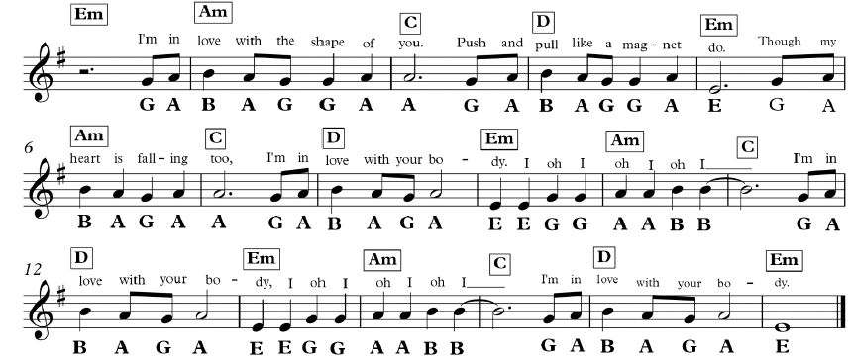30 secs

REMEMBER TO LET YOUR TEACHER HEAR YOU PLAY 2 PIECES BEFORE YOU MOVE ON!

LEVEL 4 / NATIONAL 4

Yellow

LEVEL 4/NAT 4

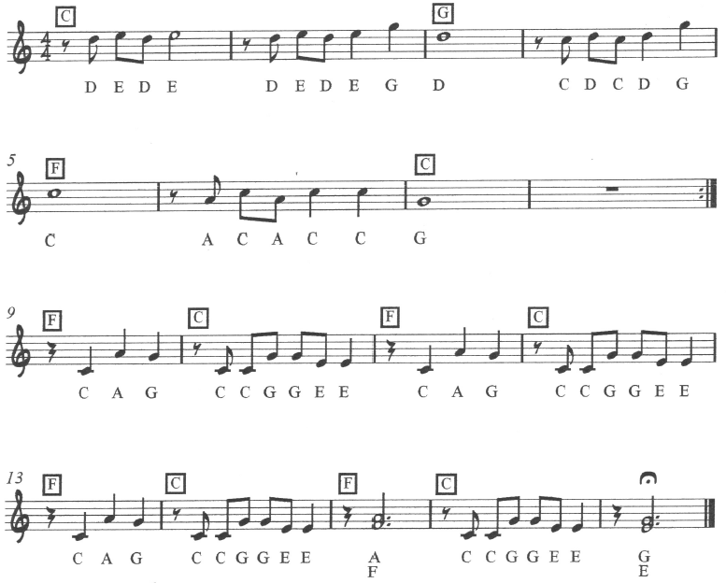1min

**Semibreve rest**

This gets 4 beats

**This is a repeat sign**

**Double note – don’t forget to play both!**

Mad World

LEVEL 4/NAT 4

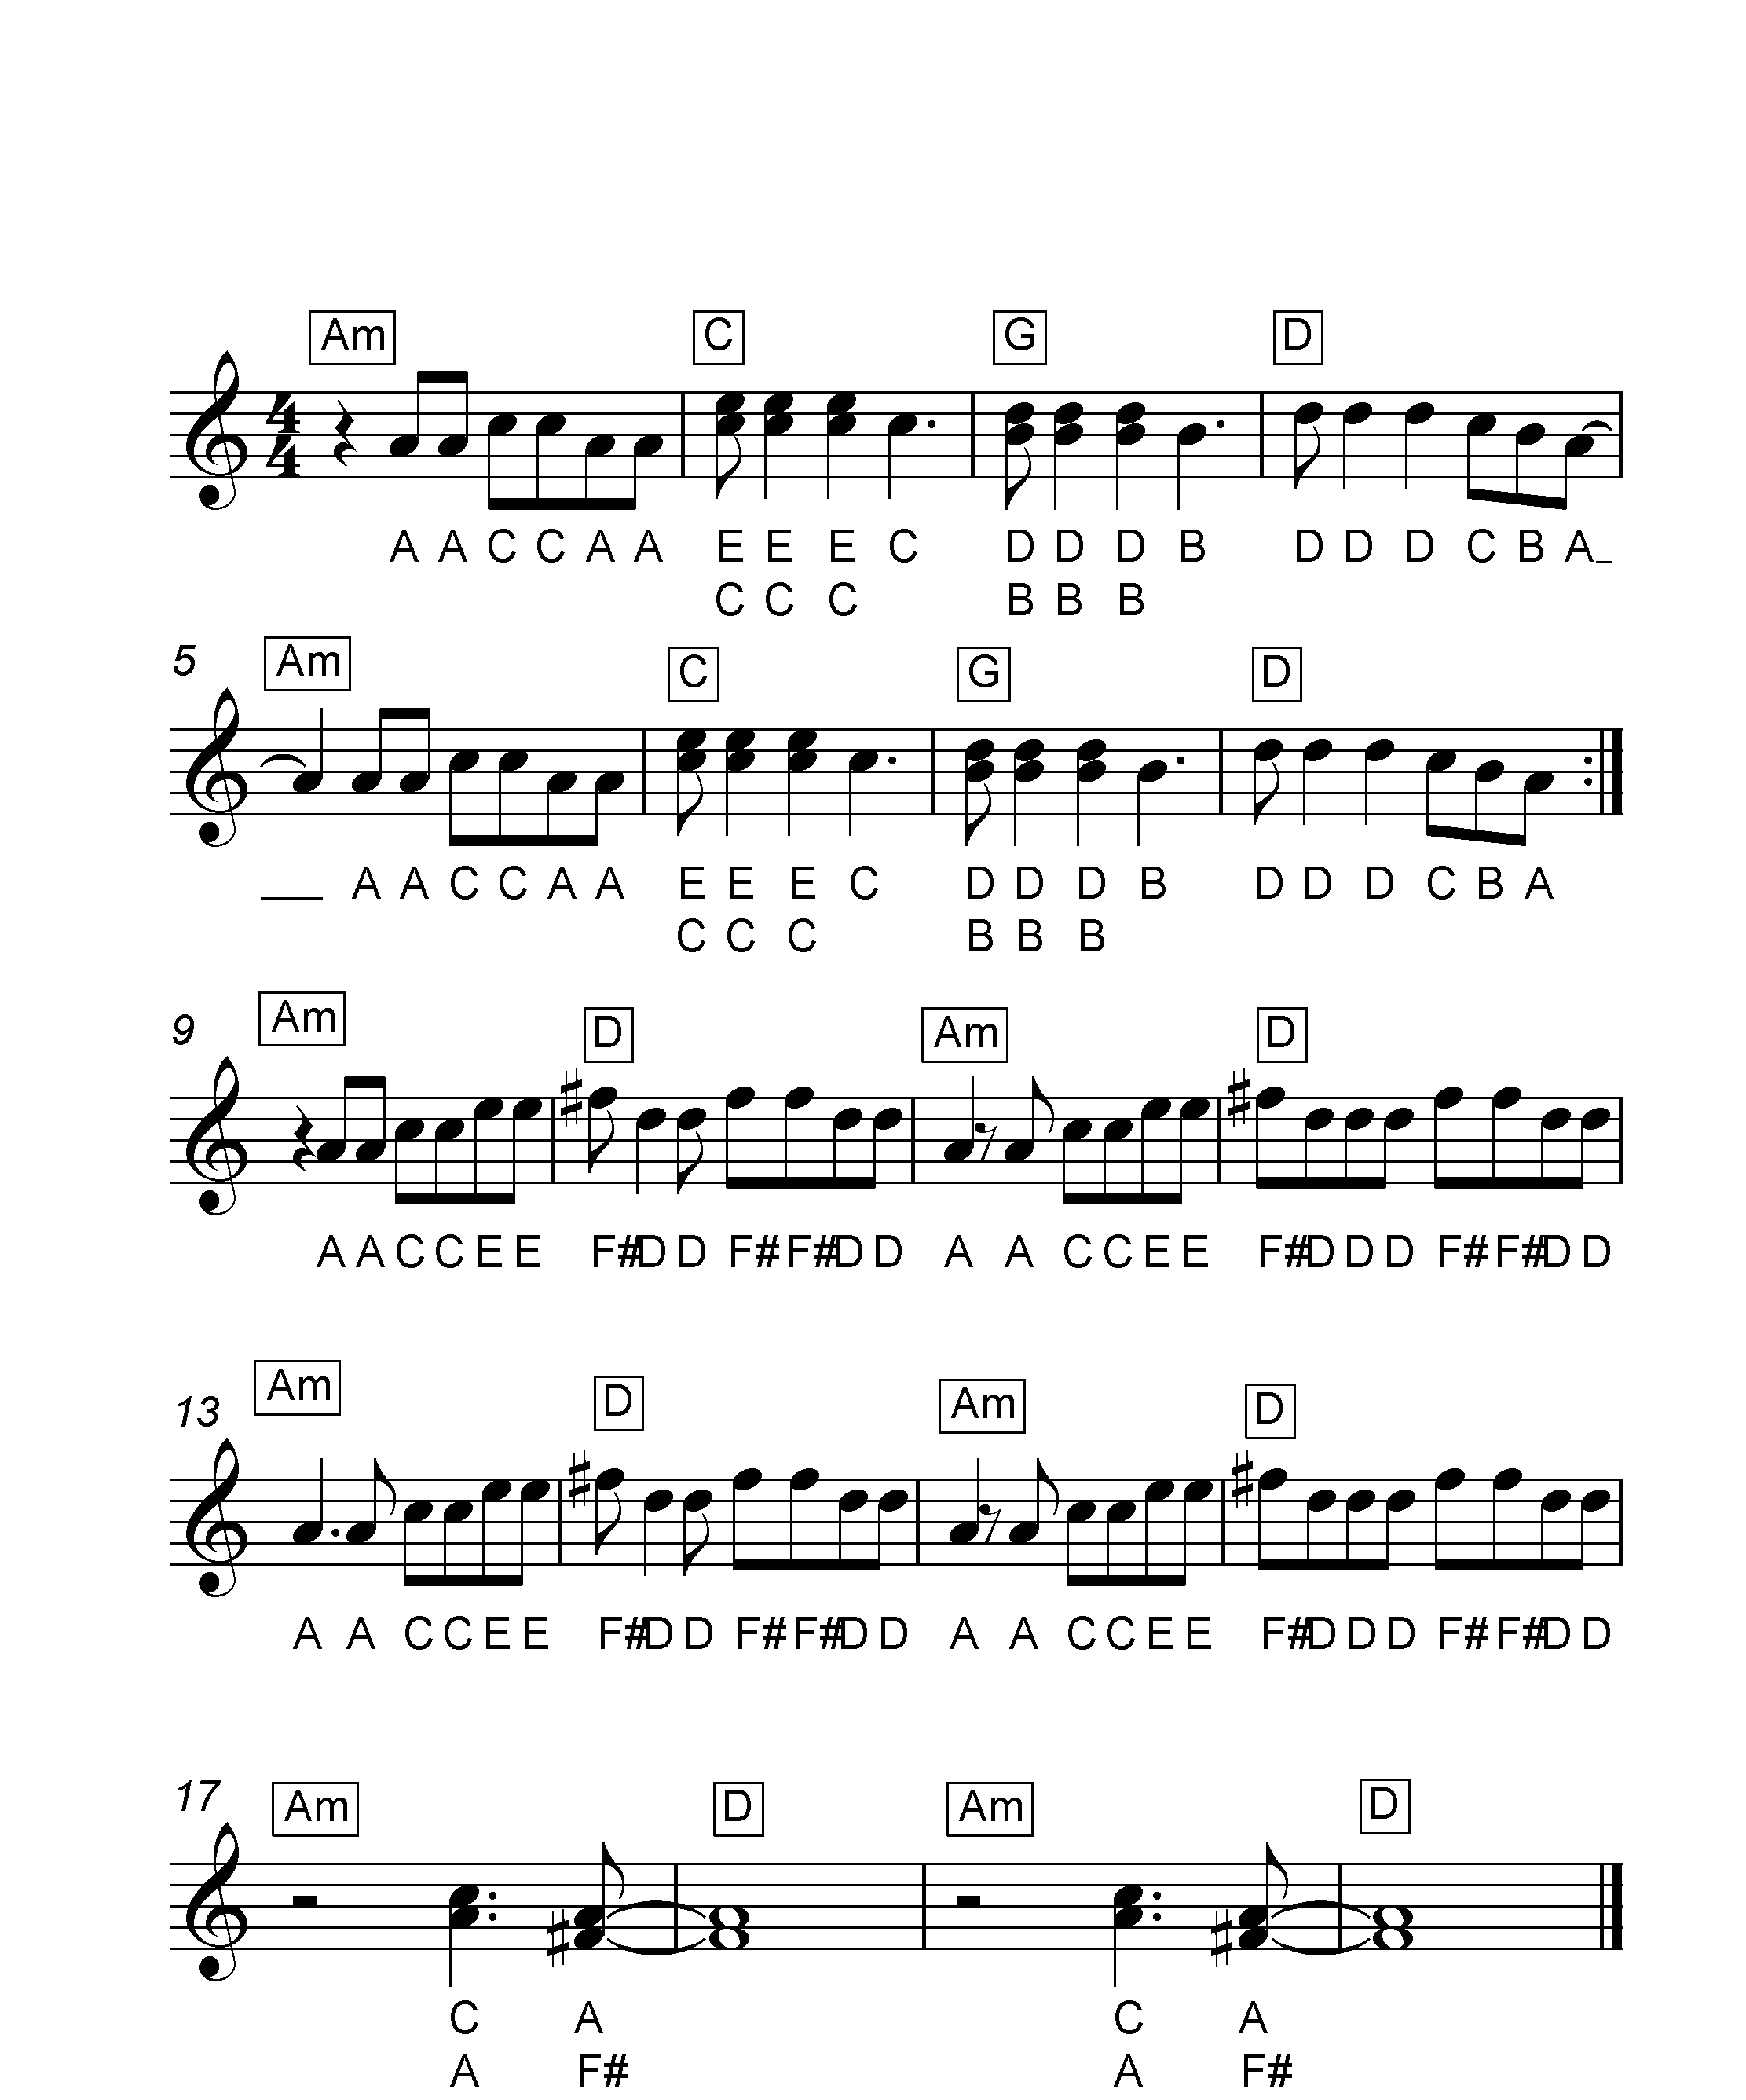1min 5

**Crotchet rest**

This gets 1 beat

Double notes – remember to play both

**This is a repeat sign**

**Minim rest**

This gets 2 beats

Pirates of the Carribean

LEVEL 4/NAT 4

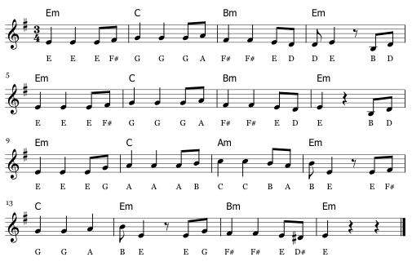40 secs

Ruby

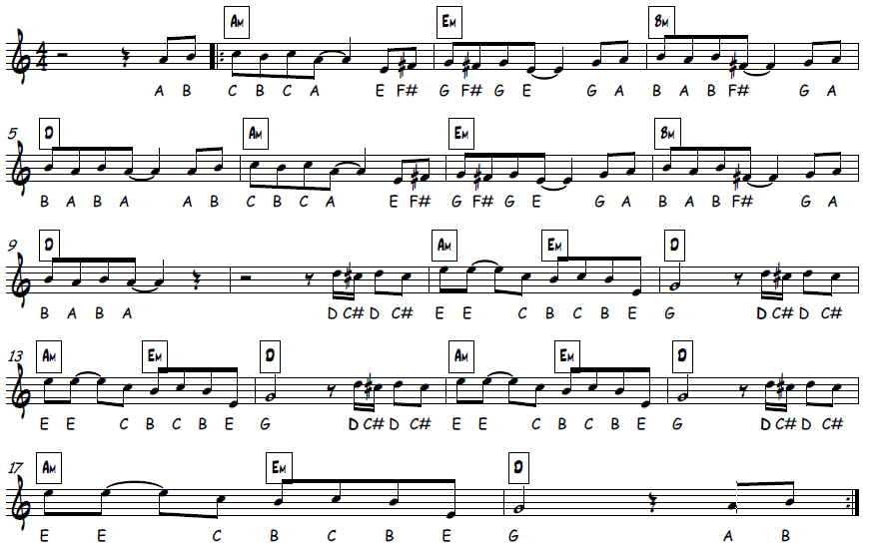LEVEL 4/NAT 4

1min 30

Highland Waltz

LEVEL 4/NAT 4

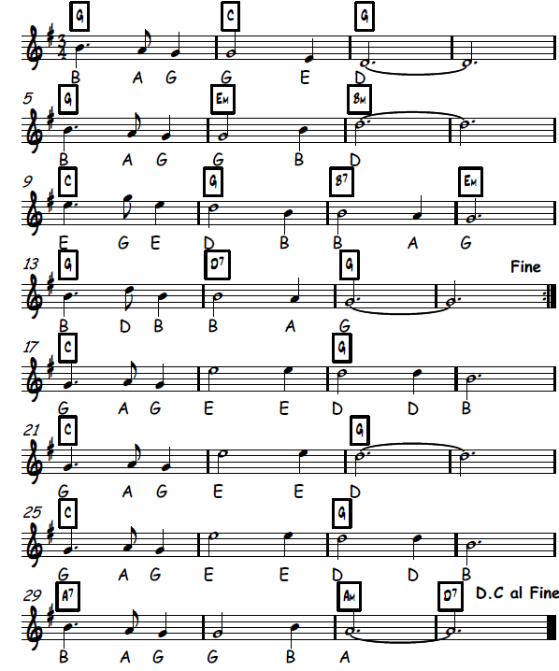2 mins

REMEMBER TO LET YOUR TEACHER HEAR YOU PLAY 2 PIECES BEFORE YOU MOVE ON!

NATIONAL 5

Little Brown Jug

NATIONAL 5

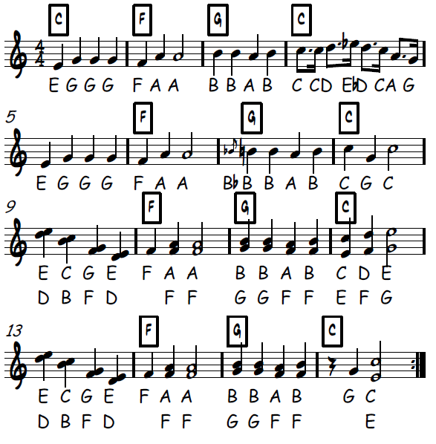1 min 5

Stitches

NATIONAL 5

1 min 40

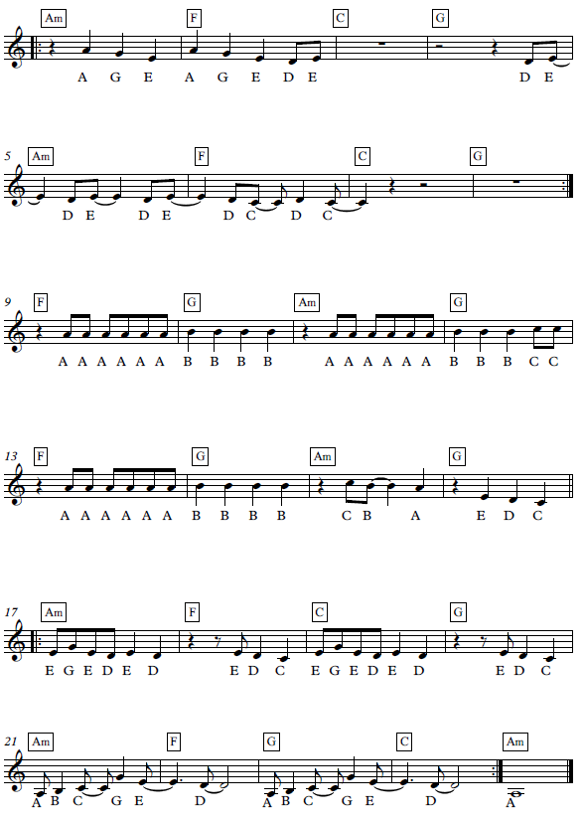

American Patrol

NATIONAL 5

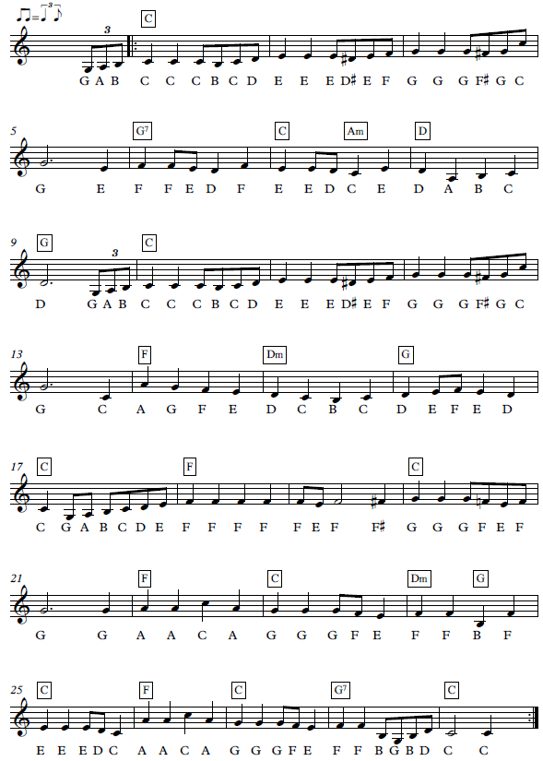2 min 20

Carnival de Paris

NATIONAL 5

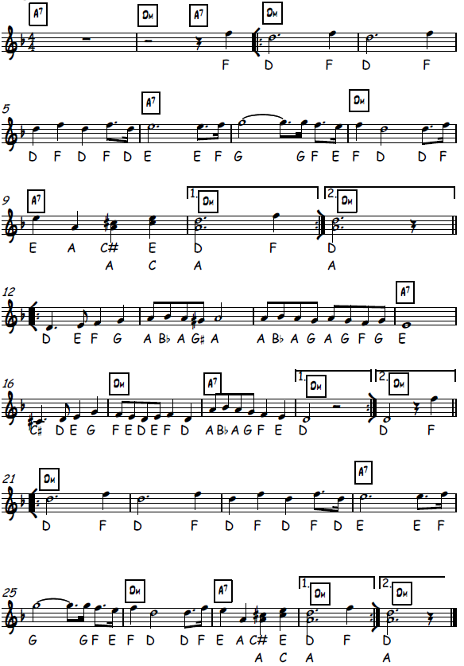2 min

Match of the Day

NATIONAL 5

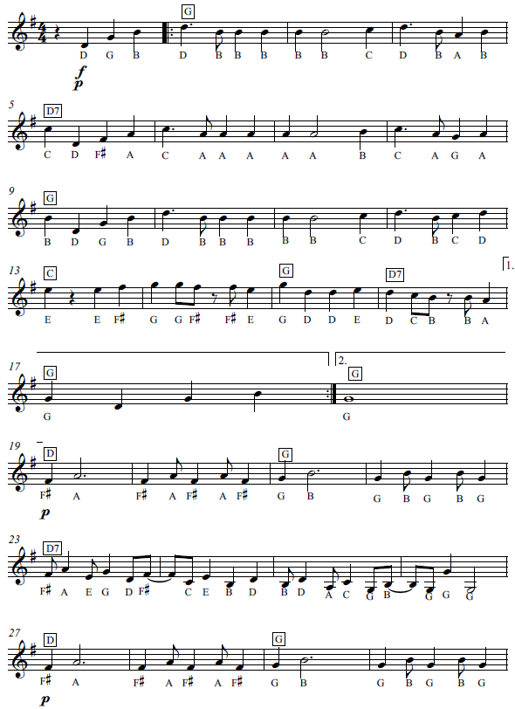1 min 55

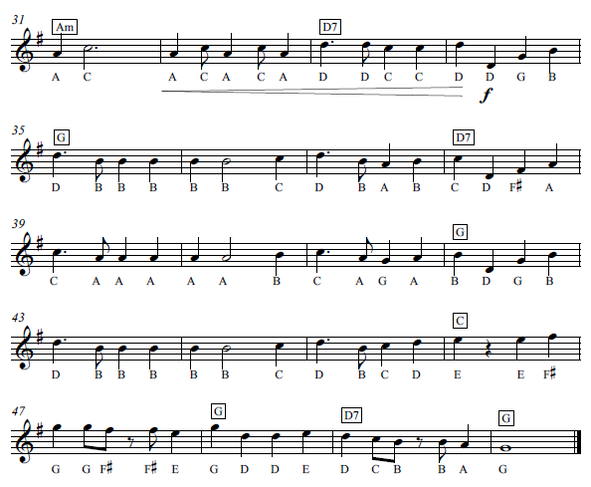

When I’m 64

NATIONAL 5

2min 45

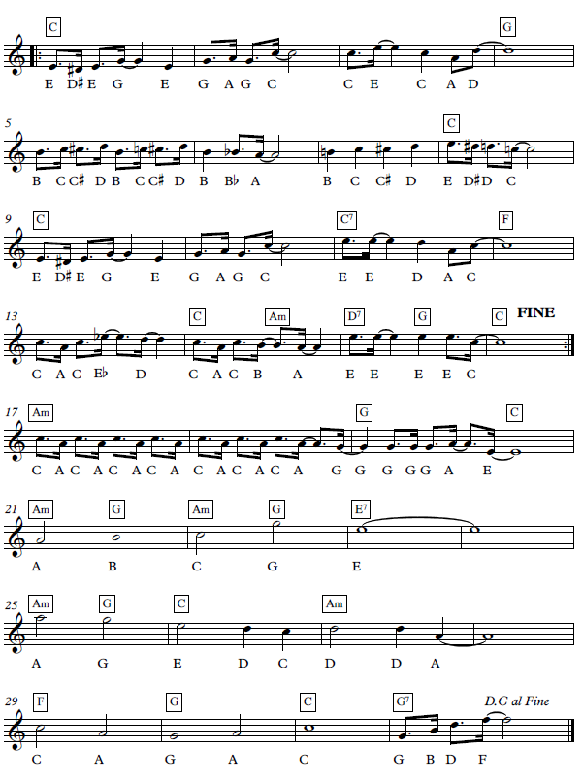

In the Hall of the Mountain King

**Sequence** – a pattern of notes repeated at a higher or lower pitch

NATIONAL 5

**Ternary Form**

A B A – 3 part form: Section A, followed by a B section which is a different melody, than a return to the A section.

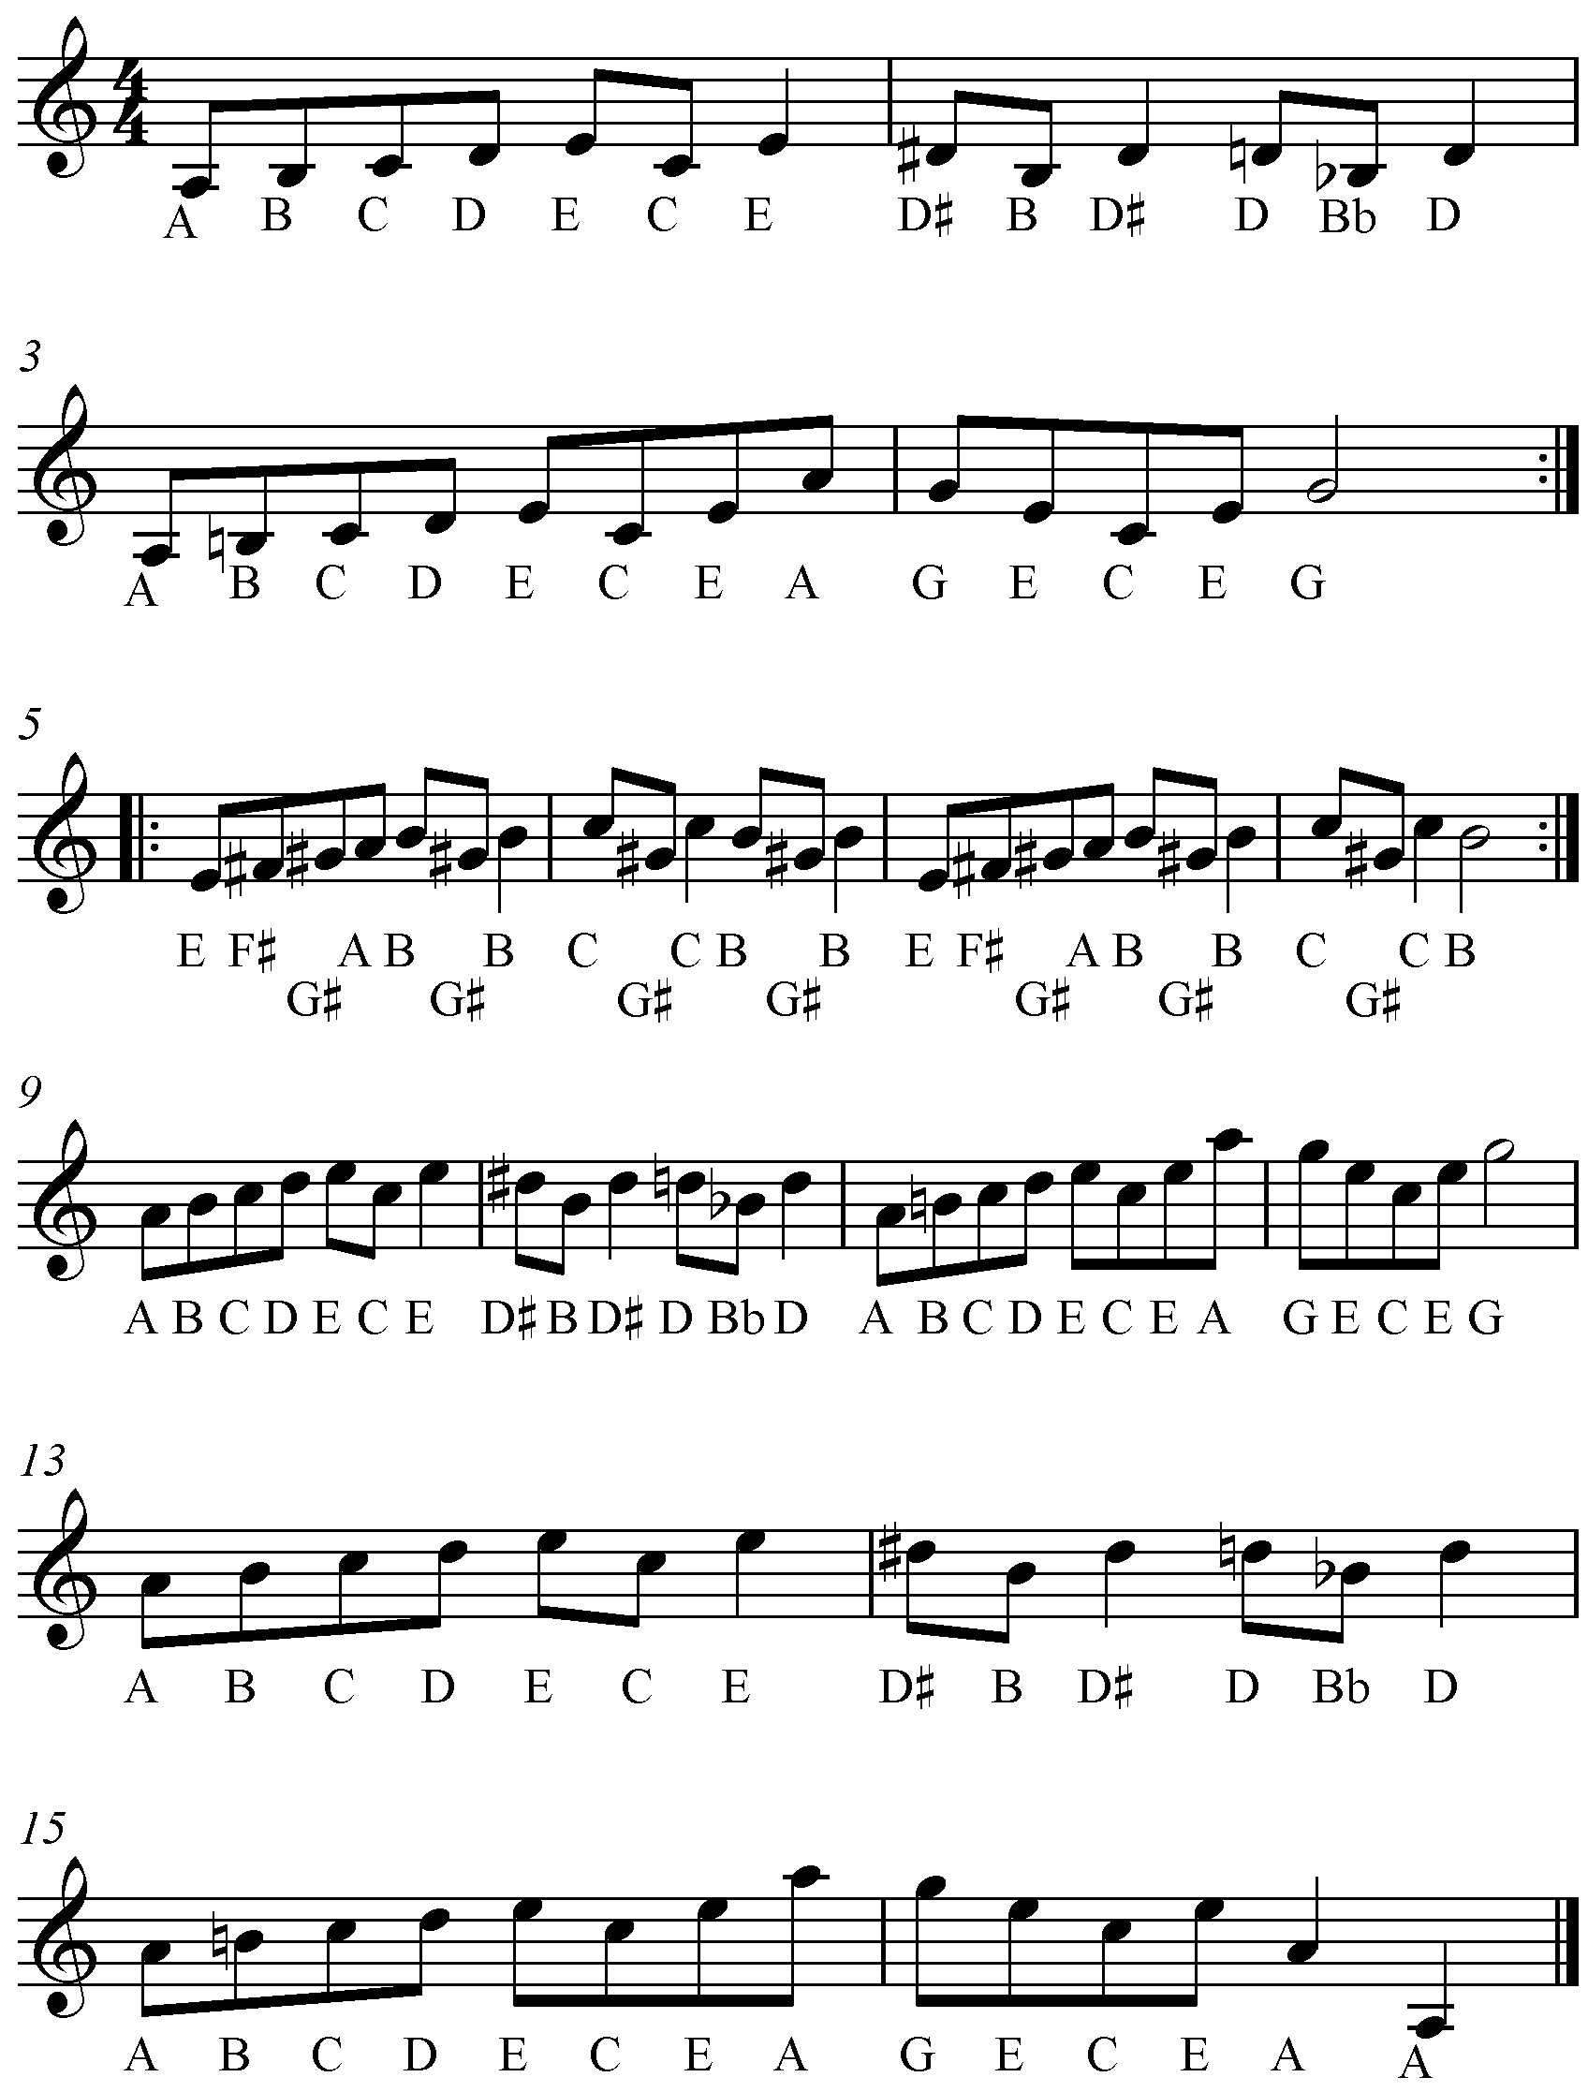1 minute

**A**

**Octave** – the distance between a note and the nearest note with the same name

An octave higher than the beginning!

**B**

**A**

Over the Rainbow

NATIONAL 5

**Ternary Form**

A B A – 3 part form: Section A, followed by a B section which is a different melody, than a return to the A section.

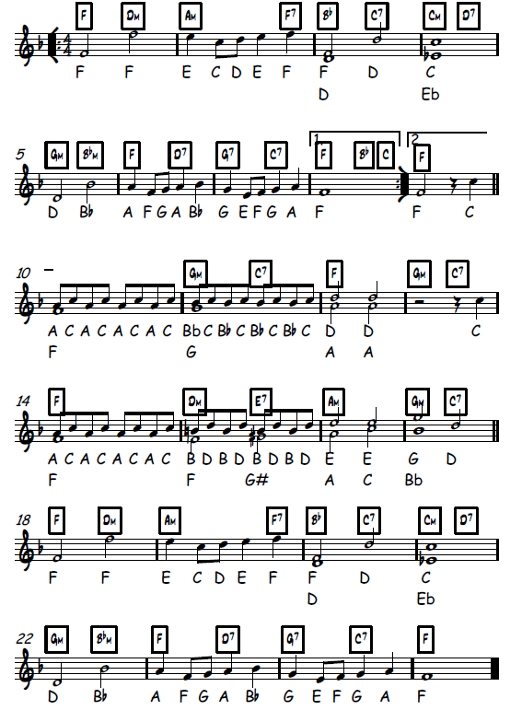1 min 30

Don’t You Want Me?

NATIONAL 5

**Ternary Form**

A B A – 3 part form: Section A, followed by a B section which is a different melody, than a return to the A section.

2 minutes

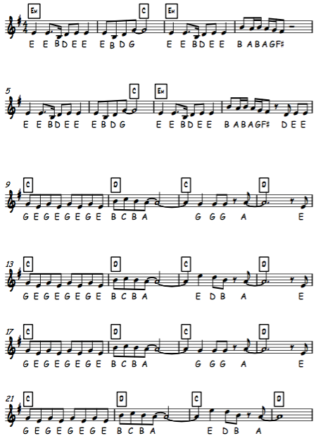

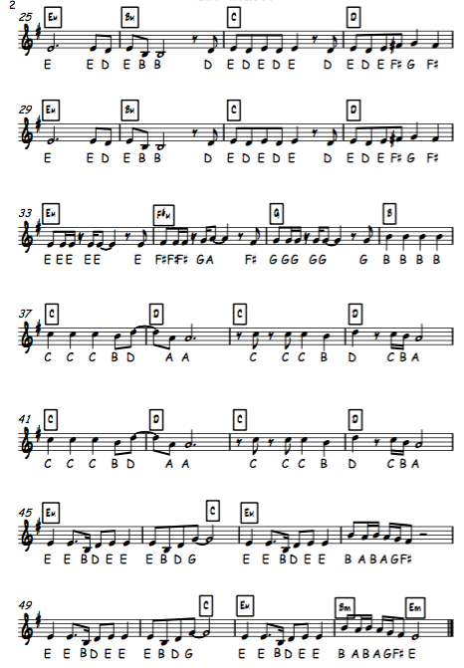

Somebody that I used to know

NATIONAL 5

**Ternary Form**

A B A – 3 part form: Section A, followed by a B section which is a different melody, than a return to the A section.

1 min 40

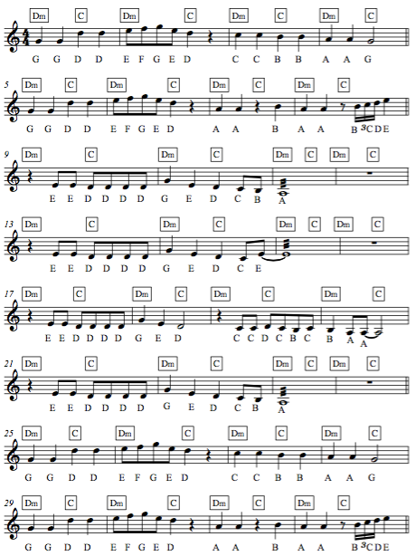

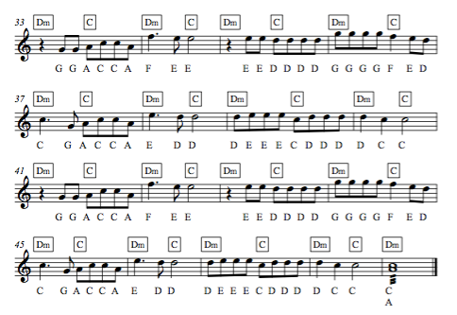

Tetris

NATIONAL 5

**Ternary Form**

A B A – 3 part form: Section A, followed by a B section which is a different melody, than a return to the A section.

1 minute

