ARDROSSAN ACADEMY

MUSIC DEPARMTENT
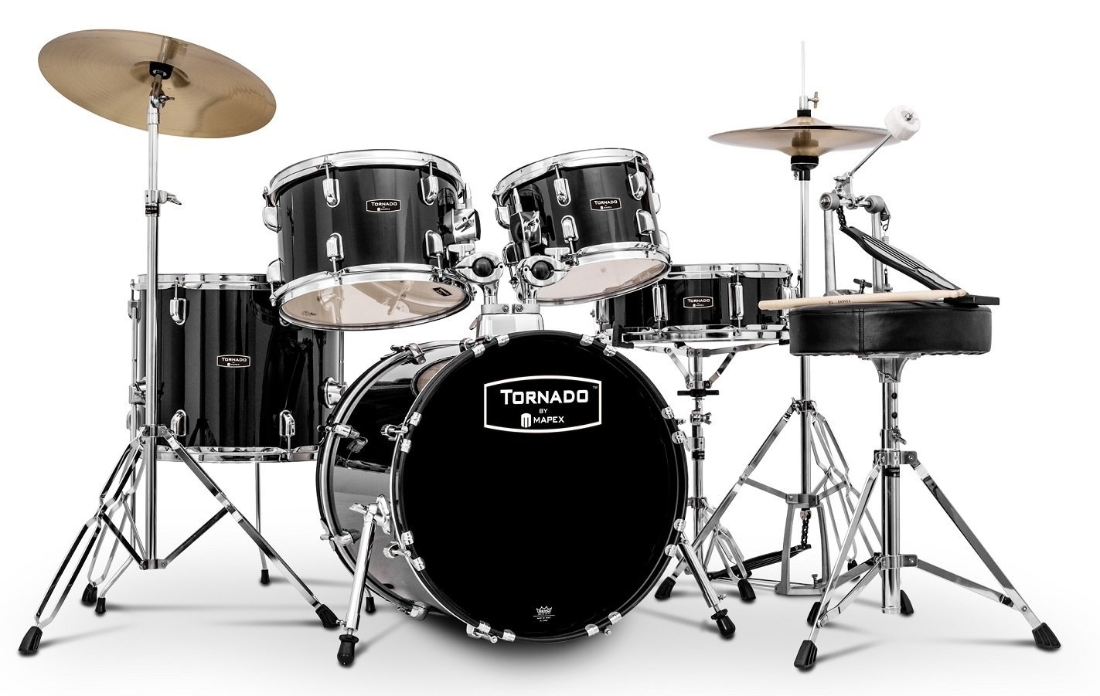
PERFORMING

LEVEL 2 – NATIONAL 5
DRUM KIT
MUSIC COURSE

Requirements
Bronze
I can play the rhythm with some accuracy. I can follow the music notation and understand where the notes are in relation to the stave. I might have to stop in my performance to check notes.

Silver
I can play the rhythm accurately most of the time, and can understand most of the information on notes and rhythms given in the notation. I have started to add a backing rhythm, and although I might lose my place at difficult sections of music, I try my best to continue.

Gold
I can play the rhythms accurately and understand how these relate to the music notation. The music flows throughout and I can play confidently along with a backing track. I have some understanding of the music symbols in the notation.

I will know I am successful when I can:
- I can hold the drum sticks correctly
- Play the rhythm accurately with good co-ordination
- I can keep a steady rhythm
- I can play along with the piano or
- I can play with a backing track

You should complete the requirements at each level and perform them for your teacher before moving on.

LEVEL 2

In the S1 ‘Tour of the Instruments’ unit, you learned to play a rock rhythm using the following grids:
Rock Rhythm Pattern 1 –
Count: | 1 | & | 2 | & | 3 | & | 4 | &
Hi-hat | X |  | X |  | X |  | X
Snare |  |  | X |  |  |  | X
Bass Drum | X |  |  |  | X
Rock Rhythm Pattern 2 –
Count: | 1 | & | 2 | & | 3 | & | 4 | &
Hi-hat | X | X | X | X | X | X | X | X
Snare |  |  | X |  |  |  | X
Bass Drum | X |  |  |  | X
Written using proper drum kit notation the patterns look like this:
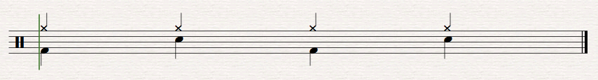
Rock Rhythm Pattern 1 –

Rock Rhythm Pattern 2 –
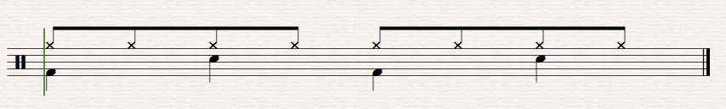

Make sure you are confident playing these rhythms 4 times in a row along with a backing track or piano and that you understand how to read the notation before you move on to the next page.
In the Tour of the Instruments unit, you also looked at a drum fill:
Rock Rhythm Fill Pattern 1 –
Count: | 1 | & | 2 | & | 3 | & | 4 | &
Snare | X | X
Tom 1 |  |  | X | X
Tom 2 |  |  |  |  | X | X
Tom 3 |  |  |  |  |  |  | X | X
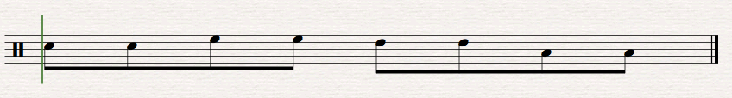
Written using proper drum kit notation the pattern looks like this:

SNARE HIGH TOM MIDDLE TOM FLOOR TOM
Play the following rhythm along with the piano or backing track:

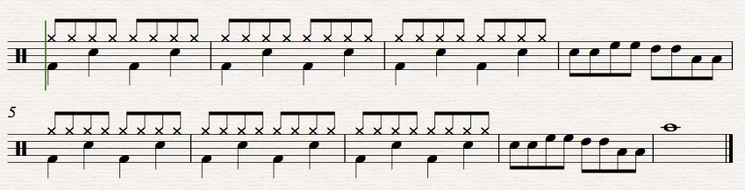

CRASH

REMEMBER TO LET YOUR TEACHER HEAR YOU PLAY BEFORE YOU MOVE ON!

LEVEL 3

NAME ____________________________________ CLASS ______________
Your teacher will give you a paper copy of this sheet. Each of the drum rhythms must be played steadily, 5 times in a row before they will be signed off.
1. Completed ____________________________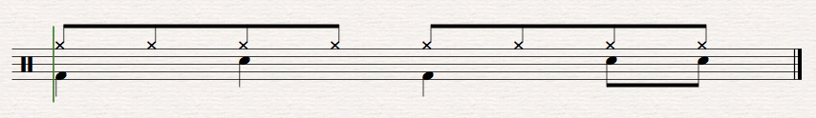
2. Completed ____________________________
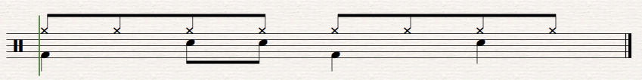
3. Completed ____________________________
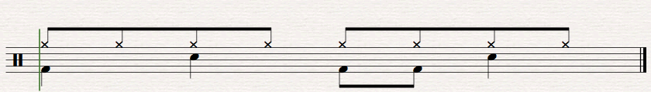
4. Completed ____________________________
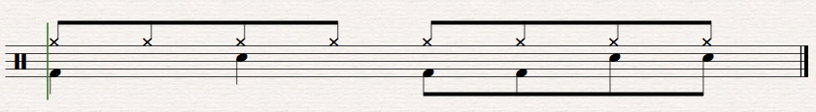
5. Completed ____________________________
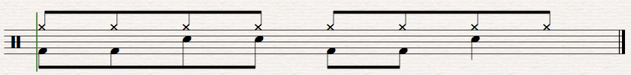

Now try the following rhythms:
REMEMBER - Each of the drum rhythms must be played steadily, 5 times in a row before they will be signed off.

1. Waltz 1 Completed _____________________________________
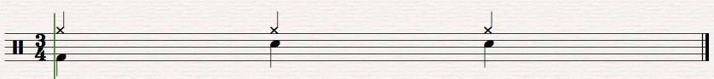

2. Waltz 2 Completed _____________________________________
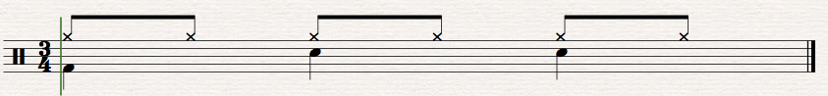

3. Blues 1 Completed _____________________________________
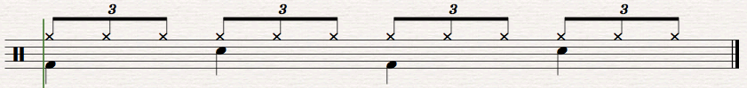
STRAWBERRY

4. Blues 2 Completed _____________________________________
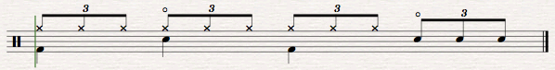
OPEN HI-HAT

OPEN HI-HAT

You should now pick 2 pieces to play to your teacher. Remember to play along with a backing track or piano accompaniment.
EASY PEASY BLUES
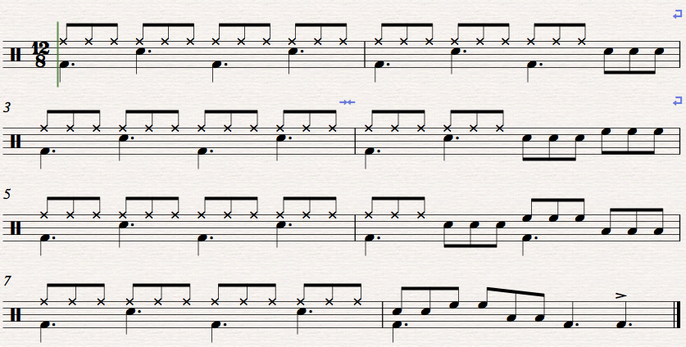

ALABAMA
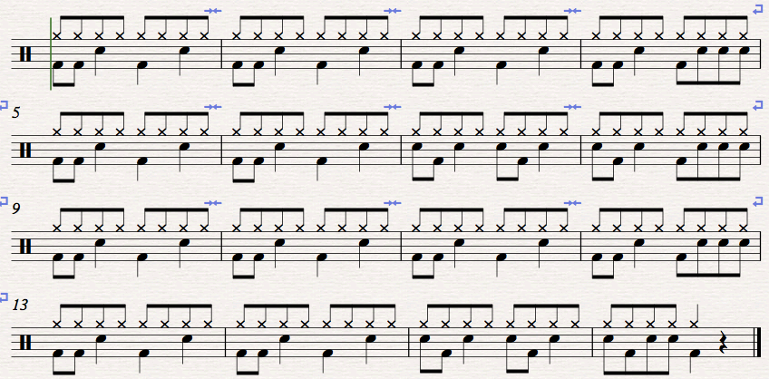

WALTZER
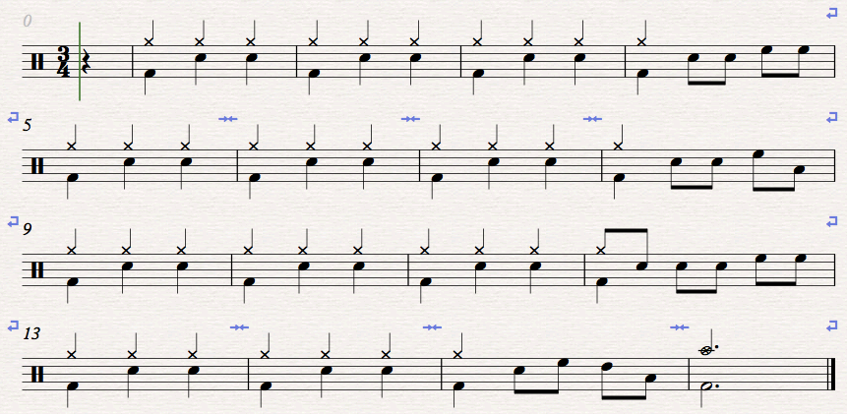

PUNK FUNK
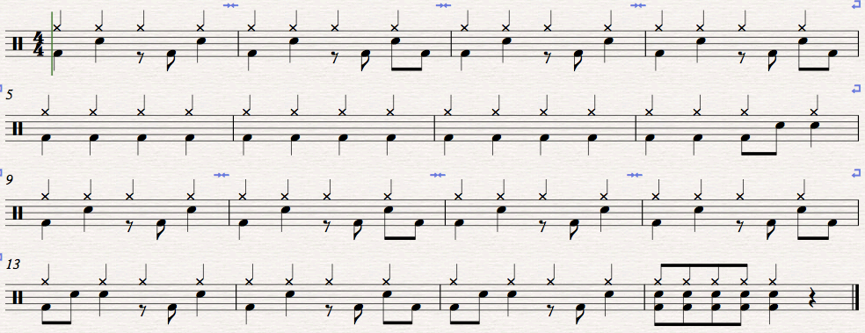

LEVEL 4
You should select 1 piece from this page and 1 other piece to play to your teacher.
EASY PEASY BLUES EXTENSION
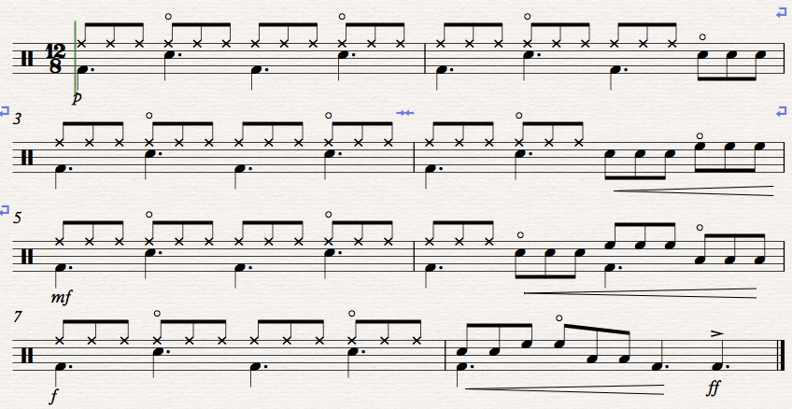

WALTZER EXTENSION
