**Higher Music Paper – 2014**

**Modified for New Higher**

**Total Marks – 40**

DO NOT WRITE IN THIS MARGIN

**MARKS**

**Attempt ALL questions**

**Question 1**

This question features orchestral music.

Listen to this excerpt and identify **three** concepts in the music from those listed below.

Read through the list before hearing the music.

Inverted pedal

Polyphonic

Plagal cadence

Coloratura

Acciaccatura

Concertino

Whole tone scale

Timpani

Give your answers on the lines below. **3**

The music will be played **twice** with a pause of 10 seconds between playings.

Here is the music for the first time.

Here is the music for the second time.

DO NOT WRITE IN THIS MARGIN

**MARKS**

**Question 2**

In this question you will hear instrumental music.

A guide to the music is shown below. You are required to complete this guide by inserting music concepts.

There will now be a pause of 30 seconds to allow you to read through the question.

The music will be played **three** times, with a pause of 20 seconds between playings. You will then have a further 30 seconds to complete your answer.

In the first two playings, a voice will help guide you through the music. There is no voice in the third playing.

Here is the music for the first time.

Here is the music for the second time.

|  |  |
| --- | --- |
| **1.** | The first two instruments are a piano and  ___________________________________. |
| **2.** | The cadence which ends this phrase is  ____________________________________. |
| **3.** | The bass line is built on ascending  ____________________________________. |
| **4.** | The rhythmic feature in the flute is  ____________________________________. |

Here is the music for the third time.

**1**

**1**

**1**

**1**

DO NOT WRITE IN THIS MARGIN

**MARKS**

**Question 3**

(a) Listen to this excerpt and identify **four** concepts in the music from those listed below.

Read through the list before hearing the music.

Mass

Coloratura

Diminished 7th

Tierce de Picardie

Plainchant

Lied

Rubato

Aria

Give your answers on the lines below. The music will be played three times with

a pause of 10 seconds between playings.

Here is the music for the first time.

Here is the music for the second time.

Here is the music for the third time. **4**

(b) Listen to the following excerpt which will be played **twice**, then write the

concept which describes the rhythm.

Here is the music for the first time.

Here is the music for the second time. **1**

DO NOT WRITE IN THIS MARGIN

**MARKS**

**Question 3 (continued)**

(c) Listen to this excerpt and identify **three** concepts in the music from those listed below.

Read through the list before hearing the music.

Chromatic

Pitch bend

Tremolando

Trill

Oboe

Sonata

Pizzicato

Concerto grosso

Give your answers on the lines below. The music will be played twice with

a pause of 10 seconds between playings and a pause of 40 seconds before

the next question starts.

Here is the music for the first time.

Here is the music for the second time. **3**

**Question 4**

DO NOT WRITE IN THIS MARGIN

**MARKS**

Listen to the song and follow the guide to the music on the opposite page.

Here is the music for the first time.

You now have 2 minutes to read the question.

(a) The piece is in the key of A minor. Describe the interval formed by the two notes in the box in bar 13. Write your answer in the box. **1**

(b) Look at **bars 19** and **20**. Write the notes **one octave lower** in the bass clef.

Use the given blank bars. **1**

(c) This question is about chord changes.

In the boxes above the stave, write the chords which you hear in **bars 3** and

**5**. You may use letter names or numbers. The chord in bar 1 is given.

Choose from the following:

Am Chord I

Dm Chord IV

E Chord V

F Chord VI **1**

(d) Insert the rest missing from **bar 11**. **1**

(e) Write “S” above where you hear this phrase starting in the strings. **1**



During the next three playings complete your answers (a) – (e).

The music will be played **three** more times with a pause of 30 seconds between

playings and a pause of 2 minutes before the next question starts.

Here is the music for the second time.

Here is the music for the third time.

Here is the music for the fourth time.

**Question 4 (continued)**

DO NOT WRITE IN THIS MARGIN

**MARKS**

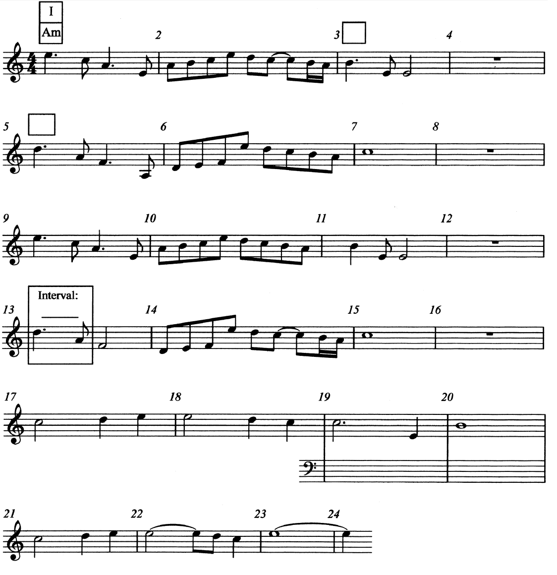

**Question 5**

DO NOT WRITE IN THIS MARGIN

**MARKS**

This question features music from the 20th century.

(a) Listen to this excerpt, which will be played **twice**, and insert the missing bar lines in the printed music below.

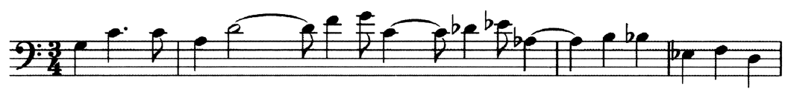

Here is the music for the first time.

Here is the music for the second time. **2**

(b)Listen to a continuation of the previous excerpt. Tick **one** box to identify

what you hear. **1**

Chamber music

Passacaglia

Minimalist

Ritornello

(c) Listen to an excerpt from a different piece. Write the concept which describes

the style. 1

(d) Listen to a different piece of music. Write the concept which describes this

style. 1

**[blank page]**

**Question 6**

DO NOT WRITE IN THIS MARGIN

**MARKS**

In this question you should identify the most prominent concepts which are present

in the music.

As you listen, identify at least **two** concepts from each of the following headings.

**Melody/Harmony Style/Period Timbre**

You will hear the music **three** times and you should make notes as you listen.

**Rough work will not be marked.**

Marks will only be awarded for the final answer.

After the third playing you will have 3 minutes to write your final answer in the space

provided.

Here is the music for the first time.

Here is the music for the second time.

Here is the music for the third time. **6**

**Rough Work**

|  |  |
| --- | --- |
| **Melody/Harmony** |  |
| **Style/Period** |  |
| **Timbre** |  |

**Question 6 (continued)**

DO NOT WRITE IN THIS MARGIN

**MARKS**

**Final Answer**

**Question 7**

DO NOT WRITE IN THIS MARGIN

**MARKS**

In this question you are asked to compare two excerpts of music.

You must first identify concepts present in each excerpt and then decide which

three concepts are common to both excerpts. Both excerpts will be played **three**

times with a pause of 10 seconds between playings.

As you listen, tick boxes in **Column A** and **Column B** to identify what you hear in

Excerpt 1 and Excerpt 2. **These columns are for rough work only and will not be**

**marked.**

After the three playings of the music you will be given 2 minutes to decide which

concepts are common to both excerpts and to tick **three** boxes in **Column C.**

You now have 1 minute to read through the question.

Here is Excerpt 1 for the first time. **Remember to tick concepts in Column A.**

Here is Excerpt 2 for the first time. **Remember to tick concepts in Column B.**

Here is Excerpt 1 for the second time.

Here is Excerpt 2 for the second time.

Here is Excerpt 1 for the third time.

Here is Excerpt 2 for the third time.

You now have 2 minutes to identify the **three** concepts common to both excerpts.

**Remember to tick three boxes only in Column C. 3**

**Question 7 (continued)**

DO NOT WRITE IN THIS MARGIN

**MARKS**

|  |  |  |  |  |
| --- | --- | --- | --- | --- |
|  | **Concepts** | **Column A**  **Excerpt 1** | **Column B**  **Excerpt 2** | **Column C**  **5 features common to both** |
| **Melody/Harmony** | Modal |  |  |  |
| Ornaments |  |  |  |
| Suspension |  |  |  |
| **Rhythm** | Anacrusis |  |  |  |
| Scotch snap |  |  |  |
| Rallentando |  |  |  |
| **Structural** | Alberti bass |  |  |  |
| Contrary motion |  |  |  |
| Ostinato |  |  |  |
| **Styles/forms** | Jig |  |  |  |
| Reel |  |  |  |
| Strathspey |  |  |  |
| Scottish |  |  |  |
|  | | | | **3 marks** |

**Question 8**

DO NOT WRITE IN THIS MARGIN

**MARKS**

This question is based on a piece of film music.

Below is a list of features which occur in the music.

There will now be a pause of 1 minute to allow you to read through the question.

The lyrics of the song are printed in the table on the opposite page. You should

insert each feature **once** in the column on the right, at the point where it occurs.

You only need to insert the underlined word.

• the choir sings in **unison** with the soloist

• a **cymbal** roll

• a **modulation** in the solo voice part

• **timpani** rolls are featured

• an example of **melisma**

• first **imitation** of the solo voice by choir

The music will now be played **three** times with a pause of 20 seconds between

playings and a pause of 30 seconds at the end.

Here is the music for the first time.

Here is the music for the second time.

Here is the music for the third time.

**Question 8 (continued)**

DO NOT WRITE IN THIS MARGIN

**MARKS**

• the choir sings in **unison** with the soloist

• a **cymbal** roll

• a **modulation** in the solo voice part

• **timpani** rolls are featured

• an example of **melisma**

• first **imitation** of the solo voice by choir

**6**

|  |  |
| --- | --- |
| When the cold of winter comes, | 1 |
| Starless night will cover day. | 2 |
| In the veiling of the sun | 3 |
| We will walk in bitter rain. | 4 |
| But in dreams | 5 |
| I can hear your name. | 6 |
| And in dreams | 7 |
| We will meet again. | 8 |
| *INSTRUMENTAL* | 9 |
| When the seas and mountains fall, | 10 |
| And we come to end of days. | 11 |
| In the dark I hear a call, | 12 |
| Calling me there, | 13 |
| I will go there | 14 |
| And back again. | 15 |
| *INSTRUMENTAL* | 16 |

**[END OF QUESTION PAPER]**